The body has various mechanisms by which it regulates the intracranial space to promote optimal brain function. Acute intracranial problems can disrupt these processes, leading to increased intracranial pressure (ICP), reduced blood flow to the brain, and brain tissue damage. This chapter discusses the mechanisms that maintain normal ICP and problems that lead to increased ICP. Head injury, brain tumors, and cerebral infections and inflammatory disorders are common problems that disrupt intracranial regulation.

Intracranial Regulation
Understanding the dynamics associated with ICP is important in caring for patients with different neurologic problems. The skull is an enclosed space with 3 essential volume components: brain tissue, blood, and cerebrospinal fluid (CSF) (Fig. 56.1). The intracellular and extracellular fluids of brain tissue make up about 78% of this volume. Blood in the arterial, venous, and capillary network makes up 12% of the volume. The remaining 10% is the volume of the CSF.
Primary versus secondary injury is an important concept in understanding ICP. Primary injury occurs at the initial time of an injury (e.g., impact of car accident, blunt-force trauma). It results in displacement, bruising, or damage to any of the components (brain tissue, blood, CSF).
Secondary injury is the resulting hypoxia, ischemia, hypotension, edema, or increased ICP that follows the primary injury. Secondary injury, which can occur several hours to days after the initial injury, is a concern when managing brain injury. Nursing management of the patient with an acute intracranial problem must include management of secondary injury and increased ICP.

Normal Intracranial Pressure
Intracranial pressure (ICP) is the hydrostatic force measured in the brain CSF compartment. Under normal conditions in which intracranial volume stays relatively constant, the balance among the 3 components (brain tissue, blood, CSF) maintains ICP. Factors that influence ICP under normal circumstances are changes in (1) arterial pressure; (2) venous pressure; (3) intraabdominal and intrathoracic pressure; (4) posture; (5) temperature; and (6) blood gases, particularly CO₂ levels. The degree to which these factors increase or decrease the ICP depends on the brain’s ability to adapt to changes.
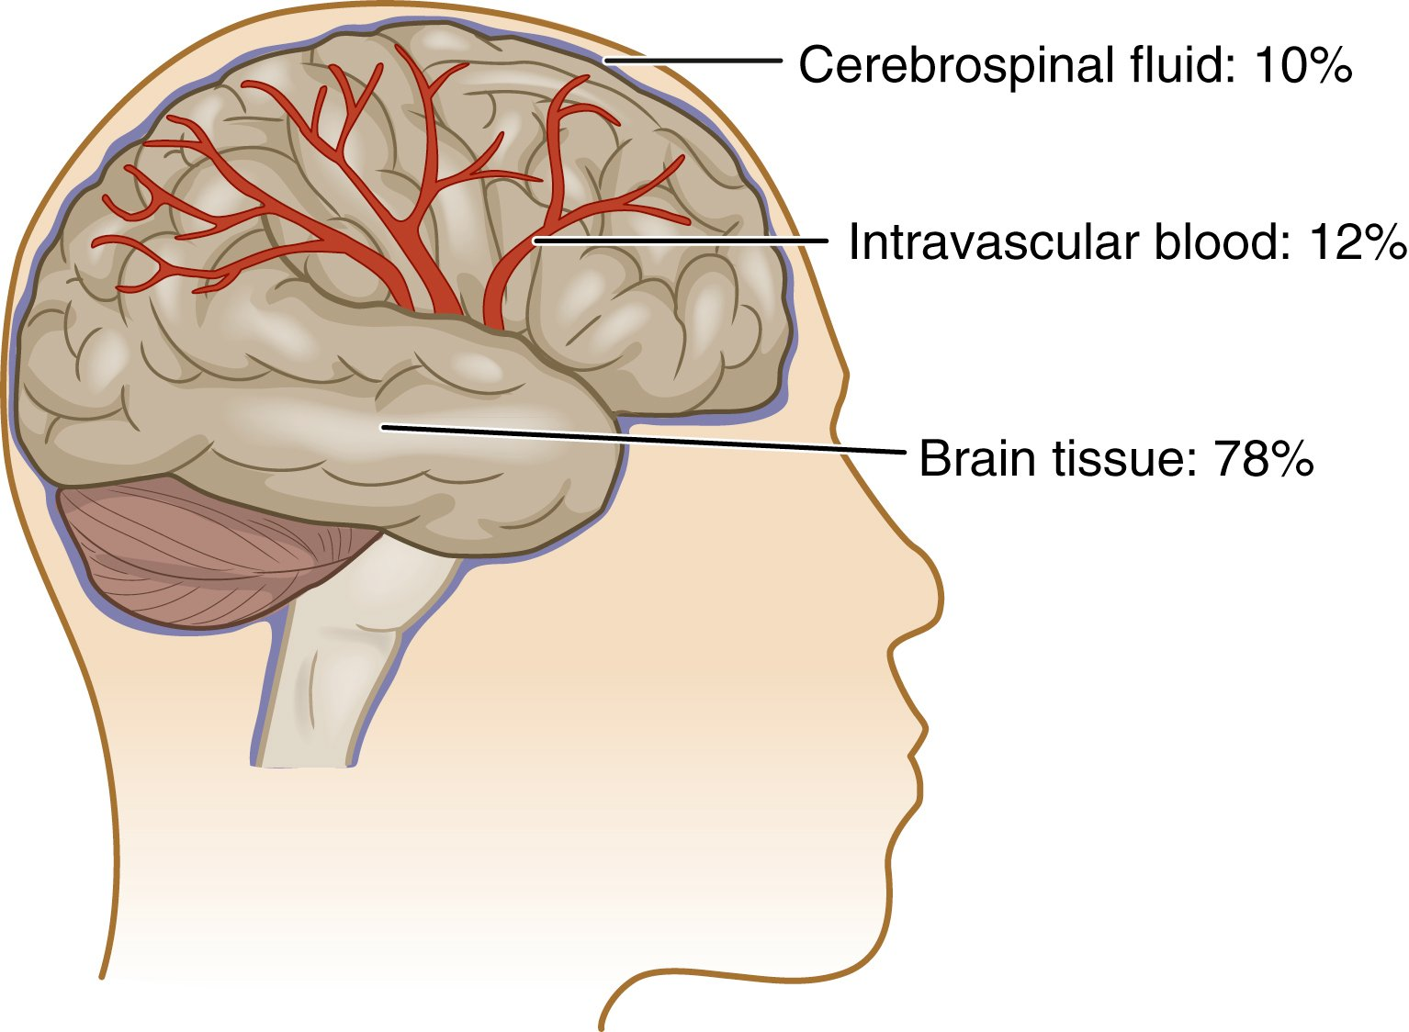FIG. 56.1 Components of the brain.
The Monro-Kellie doctrine states that the 3 components must stay at a relatively constant volume within the closed skull structure. If the volume of any 1 of the 3 components increases within the cranial vault and the volume from another component is displaced, the total intracranial volume will not change.¹ This hypothesis is applicable only in situations in which the skull is closed. The hypothesis is not valid in persons with displaced skull fractures or craniectomy (removal of part of the skull).
We can measure ICP in the ventricles, subarachnoid space, subdural space, epidural space, or brain tissue using a pressure transducer.² Normal ICP ranges from 5 to 15 mm Hg. A sustained pressure greater than 20 mm Hg is considered abnormal and must be treated.

Normal Compensatory Adaptations
In applying the Monro-Kellie doctrine, the body can adapt to volume changes within the skull in 3 different ways to maintain a normal ICP. The first compensatory mechanisms can include changes in the CSF volume. CSF volume can be changed by altering CSF absorption or production and by displacing CSF into the spinal subarachnoid space. Second, changes in intracranial blood volume can occur through the collapse of cerebral veins and dural sinuses, regional cerebral vasoconstriction or dilation, and changes in venous outflow. Third, brain tissue volume compensates through distention of the dura or compression of brain tissue.
Initially an increase in volume produces no increase in ICP because of these compensatory mechanisms. However, there is limited ability to compensate for changes in volume. As the volume increase continues, ICP rises and decompensation occurs, resulting in compression and ischemia.

Cerebral Blood Flow
Cerebral blood flow (CBF) is the amount of blood in milliliters passing through 100 g of brain tissue in 1 minute. The global CBF is about 50 mL/min/100 g of brain tissue. Maintaining blood flow to the brain is critical because the brain requires a constant supply of O₂ and glucose. The brain uses 20% of the body’s O₂ and 25% of its glucose.³
TABLE 56.1 Calculation of Cerebral Perfusion Pressure

OR

- Example: Systemic BP = 122/84 mm Hg
- MAP = 97 mm Hg
- ICP = 12 mm Hg
- CPP = 85 mm Hg
CPP, Cerebral perfusion pressure; DBP, diastolic blood pressure; MAP, mean arterial pressure; SBP, systolic blood pressure.

Autoregulation of Cerebral Blood Flow
The brain regulates its own blood flow in response to its metabolic needs despite wide fluctuations in systemic arterial pressure. Cerebral autoregulation is the automatic adjustment in the diameter of the cerebral blood vessels by the brain to maintain a constant blood flow during changes in arterial BP. The purpose of autoregulation is to ensure a consistent CBF to provide for the metabolic needs of brain tissue and maintain cerebral perfusion pressure within normal limits.
The lower limit of systemic arterial pressure at which autoregulation is effective in a normotensive person is a mean arterial pressure (MAP) of 70 mm Hg. Below this, CBF decreases, and symptoms of cerebral ischemia, such as syncope and blurred vision, occur. The upper limit of systemic arterial pressure at which autoregulation is effective is a MAP of 150 mm Hg. When this pressure is exceeded, the vessels are maximally constricted, and further vasoconstrictor response is lost.
The cerebral perfusion pressure (CPP) is the pressure needed to ensure blood flow to the brain. CPP is equal to the MAP minus the ICP (CPP = MAP − ICP) (see the example in Table 56.1). Normal CPP is 60 to 100 mm Hg. As the CPP decreases, autoregulation fails and CBF decreases. A CPP of less than 50 mm Hg is associated with ischemia and neuronal death. A CPP of less than 30 mm Hg results in ischemia and is incompatible with life.
Though CPP is clinically useful, it does not consider the effect of cerebrovascular resistance. Cerebrovascular resistance, generated by the arterioles within the cranium, links CPP and blood flow as follows:
When cerebrovascular resistance is high, blood flow to brain tissue is impaired. Transcranial Doppler is a noninvasive technique used in intensive care units (ICUs) to monitor changes in cerebrovascular resistance.
Normally, autoregulation maintains an adequate CBF and CPP by adjusting the diameter of cerebral blood vessels and metabolic factors that affect ICP. It is critical to maintain MAP when ICP is increased.
Remember that CPP may not reflect perfusion pressure in all parts of the brain. There may be local areas of swelling and compression limiting regional perfusion pressure. Thus a higher CPP may be needed for these patients to prevent localized tissue damage. For example, a patient with an acute stroke may need a higher BP, increasing MAP and CPP, to increase perfusion to the brain and prevent further tissue damage.

Factors Affecting Cerebral Blood Flow
CO₂, O₂, and hydrogen ion concentration affect cerebral blood vessel tone. An increase in the partial pressure of CO₂ in arterial blood (PaCO₂) relaxes smooth muscle, dilates cerebral vessels, decreases cerebrovascular resistance, and increases CBF. A decrease in PaCO₂ constricts cerebral vessels, increases cerebrovascular resistance, and decreases CBF.
Cerebral O₂ tension of less than 50 mm Hg results in cerebrovascular dilation. This dilation decreases cerebrovascular resistance, increases CBF, and increases O₂ tension. However, if O₂ tension is not increased, anaerobic metabolism begins, resulting in an accumulation of lactic acid. As lactic acid increases and hydrogen ions accumulate, the environment becomes more acidic. Within this acidic environment, further vasodilation occurs in a continued attempt to increase blood flow. The combination of a severely low partial pressure of O₂ in arterial blood (PaO₂) and increased hydrogen ion concentration (acidosis), which are both potent cerebral vasodilators, may produce a state in which autoregulation is lost and compensatory mechanisms do not meet tissue metabolic demands.
CBF can be affected by cardiac or respiratory arrest, systemic hemorrhage, and other pathophysiologic states (e.g., diabetic coma, encephalopathies, infections, toxicities). Regional CBF can be affected by trauma, tumors, cerebral hemorrhage, or stroke. When regional or global autoregulation is lost, CBF is no longer maintained at a constant level but is directly influenced by changes in systemic BP, hypoxia, or catecholamines.

Increased Intracranial Pressure
Any patient who becomes unconscious acutely, regardless of the cause, should be suspected of having increased ICP.

Mechanisms of Increased Intracranial Pressure
Increased ICP is a potentially life-threatening situation that results from an increase in any or all the 3 components (brain tissue, blood, CSF) within the skull. Increased ICP is clinically significant because it decreases CPP, increases risks for brain ischemia and infarction, and is associated with a poor prognosis.⁴ Common causes of increased ICP include a mass (e.g., hematoma, contusion, abscess, tumor) and cerebral edema (from brain tumors, hydrocephalus, head injury, brain inflammation).
These cerebral insults, which may result in hypercapnia, cerebral acidosis, impaired autoregulation, and systemic hypertension, increase the formation and spread of cerebral edema. This edema distorts brain tissue, further increasing the ICP, and leads to even more tissue hypoxia and acidosis. Fig. 56.2 shows the progression of increased ICP.
It is critical to maintain CBF to preserve tissue and thus minimize secondary injury. Sustained increases in ICP result in brainstem compression and herniation of the brain. Herniation occurs as the brain tissue is forcibly shifted from the compartment of greater pressure to a compartment of lesser pressure.
Displacement and herniation of brain tissue can cause a potentially reversible process to become irreversible. Ischemia and edema are further increased, compounding the preexisting problem. Compression of the brainstem and cranial nerves may be fatal. Fig. 56.3 shows types of herniation. Herniation forces the cerebellum and brainstem downward through the foramen magnum. If compression of the brainstem is unrelieved, respiratory arrest will occur due to compression of the respiratory control center in the medulla. In this situation, intense pressure is placed on the brainstem. If herniation continues, brainstem death is imminent.
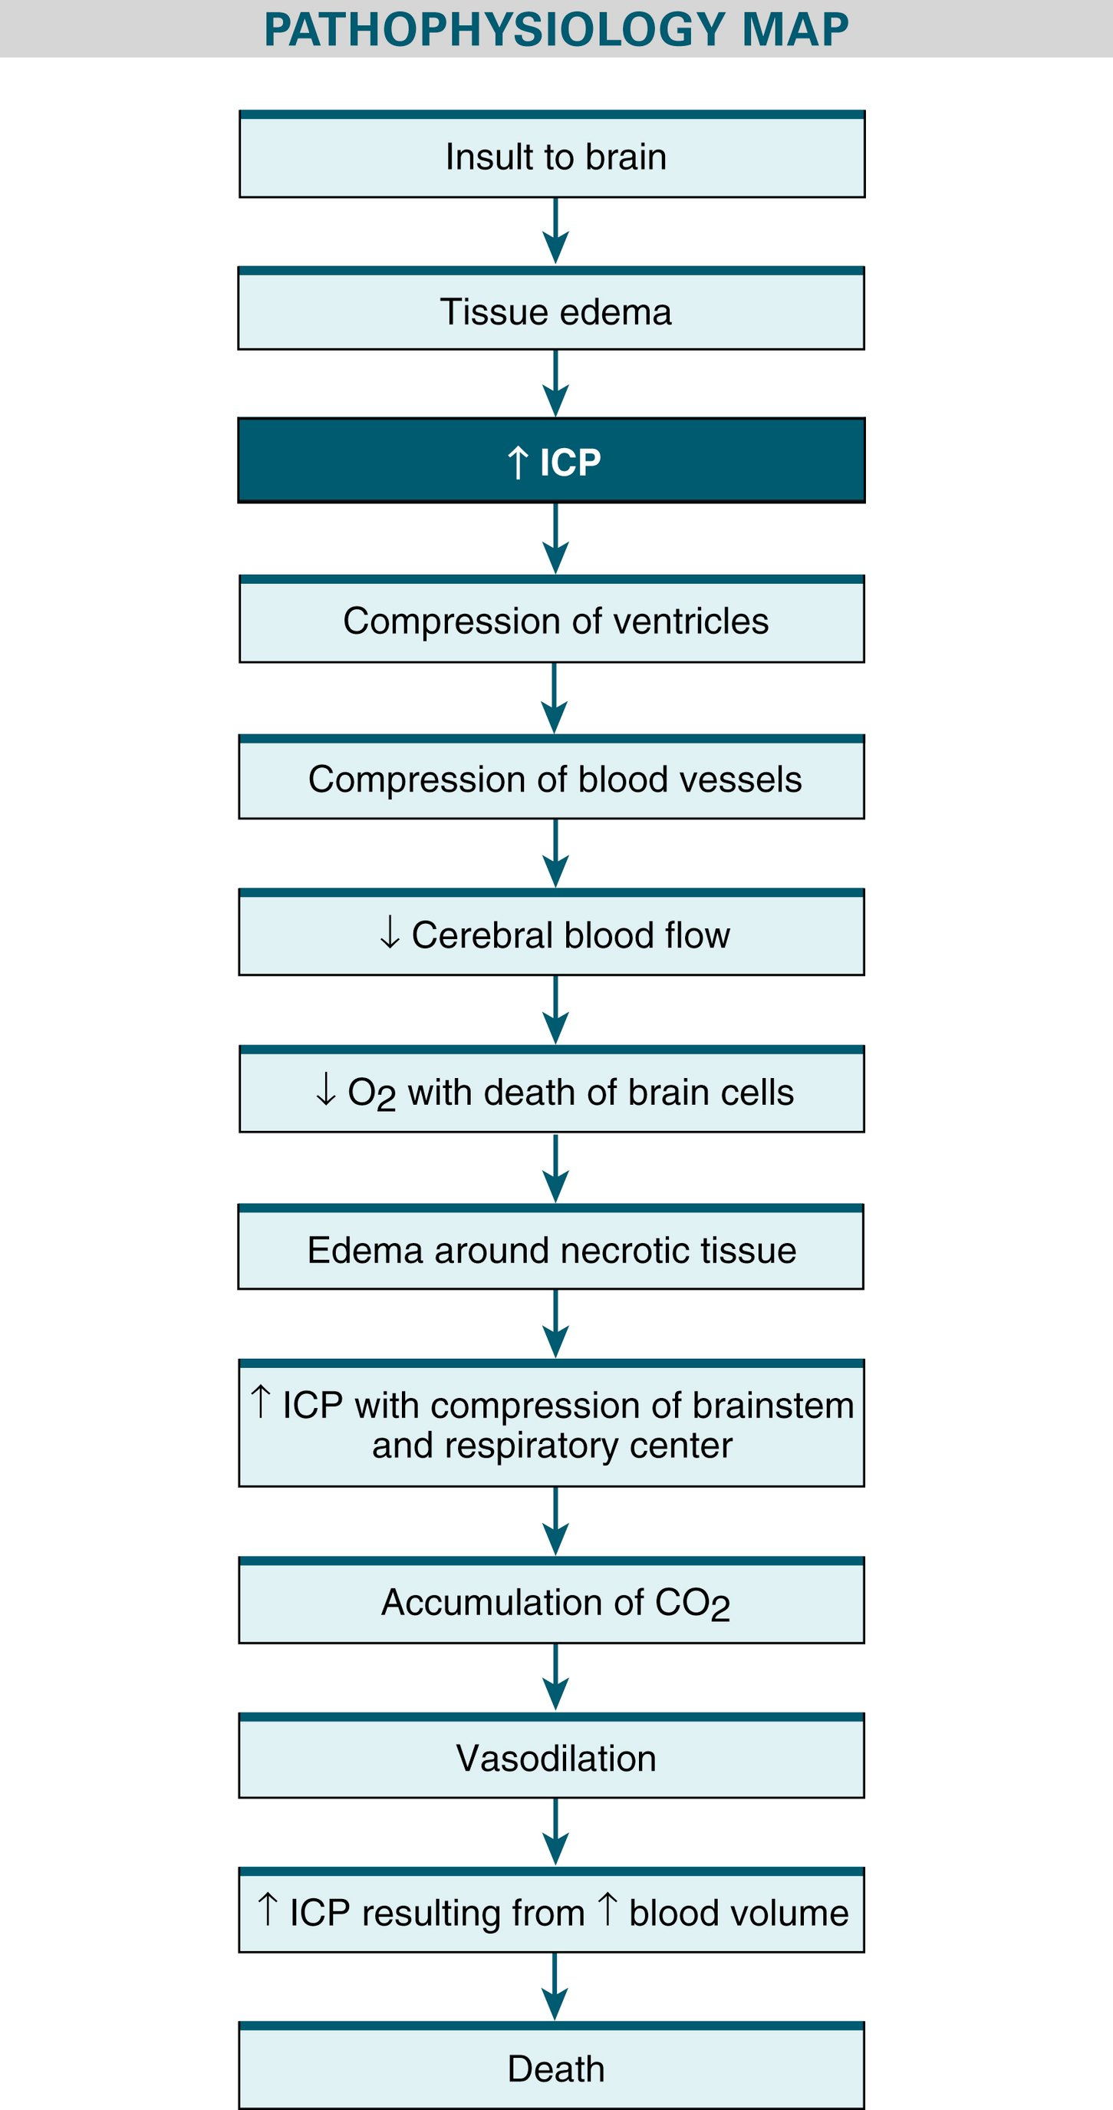FIG. 56.2 Progression of increased ICP.

Cerebral Edema
There are a variety of causes of cerebral edema (increased accumulation of fluid in the extravascular spaces of brain tissue) (Table 56.2). Regardless of the cause, cerebral edema results in an increase in tissue volume that can increase ICP. The extent and severity of the original insult are factors that determine the degree of cerebral edema.
There are 3 types of cerebral edema: vasogenic, cytotoxic, and interstitial. The same patient may have more than 1 type.
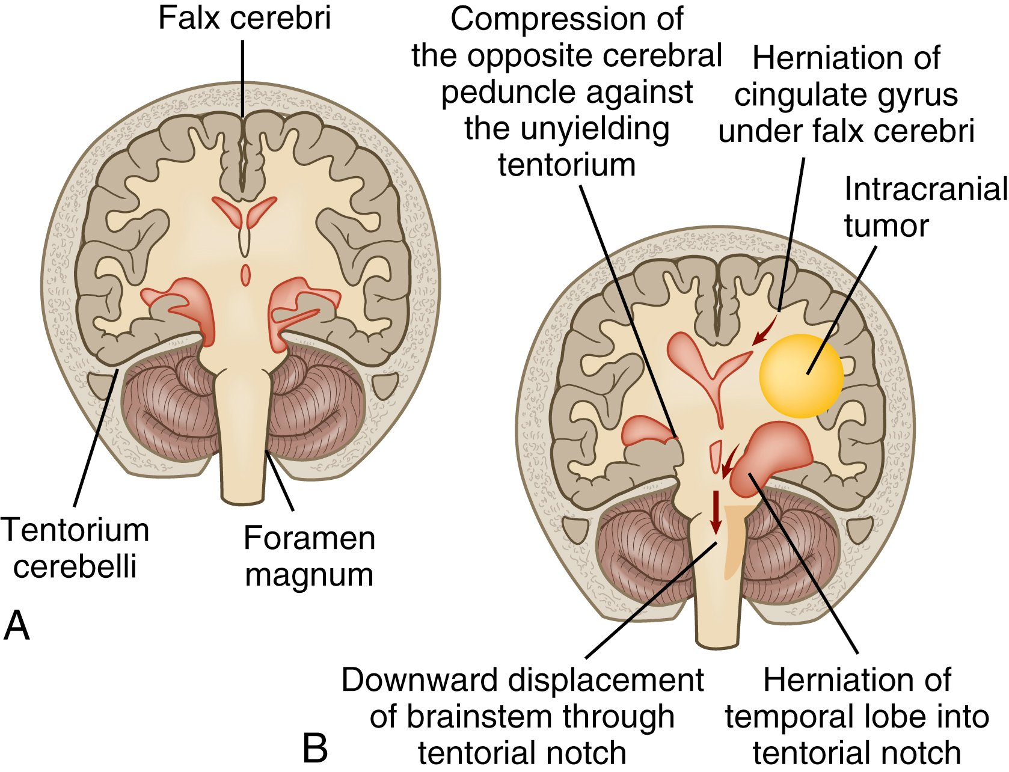FIG. 56.3 Herniation. A, Normal relationship of intracranial structures. B, Shift of intracranial structures.
Modified from McCance KL, Huether SE: Pathophysiology: The biologic basis for disease in adults and children, ed 6, St Louis, 2010, Mosby.
TABLE 56.2 Causes of Cerebral Edema
Cerebral Infections
- • Encephalitis
- • Meningitis
Head Injuries and Brain Surgery
- • Contusion
- • Hemorrhage
- • Posttraumatic brain swelling
Mass Lesions
- • Brain abscess
- • Brain tumor (primary, metastatic)
- • Hematoma (intracerebral, subdural, epidural)
- • Hemorrhage (intracerebral, cerebellar, brainstem)
Toxic or Metabolic Encephalopathic Conditions
- • Hepatic encephalopathy
- • Lead or arsenic intoxication
- • Uremia
Vascular Insult
- • Anoxic and ischemic episodes
- • Cerebral infarction (thrombotic or embolic)
- • Venous sinus thrombosis

Vasogenic Cerebral Edema
Vasogenic cerebral edema, the most common type of cerebral edema, occurs mainly in the white matter. It is characterized by leakage of large molecules from the capillaries into the surrounding extracellular space. This results in an osmotic gradient that favors the flow of fluid from the intravascular to extravascular space. A variety of problems, such as brain tumors, abscesses, and ingested toxins, may increase in the permeability of the blood-brain barrier and produce an increase in the extracellular fluid volume. The speed and extent of the spread of the edema are influenced by the systemic BP, site of the brain injury, and extent of the blood-brain barrier defect.
This edema may produce a continuum of symptoms, ranging from headache to a decrease in consciousness, including coma (profound state of unconsciousness) and focal neurologic deficits.
It is important to recognize that although a headache may seem to be a benign symptom, in cases of cerebral edema it can quickly progress to coma and death. So, you must be vigilant in your assessment.

Cytotoxic Cerebral Edema
Cytotoxic cerebral edema results from disruption of the integrity of the cell membranes. It develops from destructive lesions or trauma to brain tissue, resulting in cerebral hypoxia or anoxia and syndrome of inappropriate antidiuretic hormone (SIADH) secretion. In this type of edema, the blood-brain barrier stays intact. Cerebral edema occurs from fluid and protein shifts from the extracellular space directly into the cells, with subsequent swelling and loss of cellular function.

Interstitial Cerebral Edema
Interstitial cerebral edema is usually a result of hydrocephalus. Hydrocephalus is a buildup of fluid in the brain. It is manifested by ventricular enlargement. It can be due to excess CSF production, obstruction of flow, or an inability to reabsorb the CSF. Hydrocephalus treatment usually consists of a ventriculostomy or ventriculoperitoneal shunt. Management of hydrocephalus is discussed later in this chapter on p. 1319.

Clinical Manifestations
The manifestations of increased ICP can take many forms, depending on the cause, location, and rate of increases in ICP.

Change in Level of Consciousness
The level of consciousness (LOC) is the most sensitive and reliable indicator of the patient’s neurologic status. Changes in LOC are a result of impaired CBF, which causes O₂ deprivation to the cells of the cerebral cortex and reticular activating system (RAS). The RAS is found in the brainstem, with neural connections to many parts of the nervous system. An intact RAS can maintain a state of wakefulness even in the absence of a functioning cerebral cortex. Interruptions of impulses from the RAS or changes in functioning of the cerebral hemispheres can cause unconsciousness, an abnormal state of complete or partial unawareness of self or environment.
The patient’s state of consciousness is defined by the patient’s clinical responses and pattern of brain activity (recorded by an electroencephalogram [EEG]). A change in consciousness may be dramatic (as in coma) or subtle (e.g., flattening of affect, change in orientation, decrease in level of attention). In the deepest state of unconsciousness (e.g., coma), the patient does not respond to painful stimuli. Corneal and pupillary reflexes are absent. The patient cannot swallow or cough and is incontinent of urine and feces. The EEG pattern shows suppressed or absent neuronal activity.

Changes in Vital Signs
Increasing pressure on the thalamus, hypothalamus, pons, and medulla causes changes in vital signs.
Manifestations such as Cushing’s triad (systolic hypertension with a widening pulse pressure, bradycardia with a full and bounding pulse, irregular respirations) may be present but often do not appear until ICP has been increased for some time or is suddenly and markedly increased (e.g., head trauma). Always recognize Cushing’s triad as a medical emergency as it is a sign of brainstem compression and impending death. A change in body temperature may occur because increased ICP affects the hypothalamus.
Check Your Practice
You are monitoring the vital signs of an 82-yr-old woman who was admitted for a head injury after she fell while walking on the sidewalk. She hit her head on a fire hydrant. She was confused on admission, but vital signs were stable at BP 150/86, pulse 84, respirations 14/min. 2 hours after admission, her vital signs are now BP 166/74, pulse 54, respirations 10 to 16/min.
- • What is your interpretation of her vital signs?

Ocular Signs
Compression of cranial nerve (CN) III, the oculomotor nerve, results in dilation of the pupil on the same side (ipsilateral) as the mass lesion, sluggish or no response to light, inability to move the eye upward and adduct, and ptosis of the eyelid. These signs can be the result of the brain shifting from midline, compressing the trunk of CN III, and paralyzing the muscles controlling pupillary size and shape. In this situation, a fixed, unilateral, dilated pupil is considered a neurologic emergency that indicates brain herniation.
Other cranial nerves may be affected, including the optic (CN II), trochlear (CN IV), and abducens (CN VI) nerves. Signs of problems with these cranial nerves include blurred vision, diplopia, and changes in extraocular eye movements. Central herniation may initially manifest as sluggish but equal pupil response. Uncal herniation may cause a dilated unilateral pupil. Papilledema (an edematous optic disc seen on retinal examination) is a nonspecific sign associated with persistent increases in ICP.

Decrease in Motor Function
As the ICP continues to rise, the patient has changes in motor ability. A contralateral (opposite side of the mass lesion) hemiparesis or hemiplegia may develop, depending on the location of the source of the increased ICP. If painful stimuli are used to elicit a motor response, the patient may localize to the stimuli or withdraw from it.
Noxious stimuli may elicit decorticate (flexor) or decerebrate (extensor) posturing (Fig. 56.4). Decorticate posture consists of internal rotation and adduction of the arms with flexion of the elbows, wrists, and fingers. It is a result of interruption of voluntary motor tracts in the cerebral cortex. Extension of the legs may be seen. A decerebrate posture may indicate more serious damage. It results from disruption of motor fibers in the midbrain and brainstem. In this position, the arms are stiffly extended, adducted, and hyperpronated. There is hyperextension of the legs with plantar flexion of the feet.

Headache
Although the brain itself is insensitive to pain, compression of other intracranial structures, such as arteries, veins, and cranial nerves, can cause a headache. A nocturnal headache and/or a headache in the morning is cause for concern and may indicate a tumor or other space-occupying lesion that is causing increased ICP. Straining, agitation, or movement may worsen the pain.
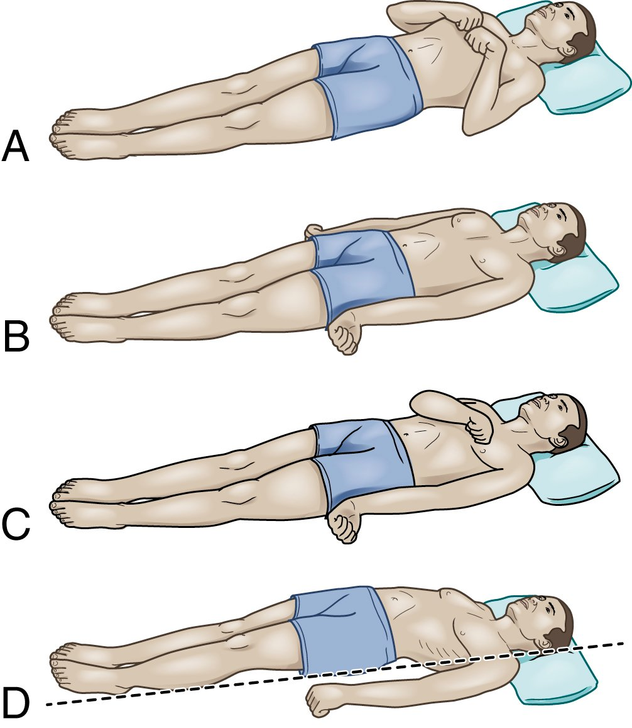FIG. 56.4 Decorticate and decerebrate posturing. A, Decorticate response. Flexion of arms, wrists, and fingers with adduction in upper extremities. Extension, internal rotation, and plantar flexion in lower extremities. B, Decerebrate response. All 4 extremities in rigid extension, with hyperpronation of forearms and plantar flexion of feet. C, Decorticate response on right side of body and decerebrate response on left side of body. D, Opisthotonic posturing.

Vomiting
Vomiting, usually not preceded by nausea, is often a nonspecific sign of increased ICP. This is called unexpected vomiting and is related to pressure changes in the cranium. Projectile vomiting may occur and is related to increased ICP.

Complications
The major complications of uncontrolled increased ICP are inadequate cerebral perfusion and cerebral herniation (Fig. 56.3). To better understand cerebral herniation, 2 important structures in the brain must be described. The falx cerebri is a thin wall of dura that folds down between the cortex, separating the 2 cerebral hemispheres. The tentorium cerebelli is a rigid fold of dura that separates the cerebral hemispheres from the cerebellum (Fig. 56.3). It is called the tentorium (meaning tent) because it forms a tentlike cover over the cerebellum.
Tentorial herniation (central herniation) occurs when a mass lesion in the cerebrum forces the brain to herniate downward through the opening created by the brainstem. Uncal herniation occurs when there is lateral and downward herniation. Cingulate herniation occurs when there is lateral displacement of brain tissue beneath the falx cerebri.

Diagnostic Studies
Diagnostic studies can be used to identify the cause of increased ICP (Table 56.3). CT and MRI are used to discern the many conditions that can cause increased ICP and assess the effect of treatment.
TABLE 56.3 Interprofessional CareIncreased Intracranial Pressure
Diagnostic Assessment
- • History and physical examination
- • Vital signs, neurologic assessments, ICP measurements
- • Skull, chest, and spinal x-ray studies
- • CT scan, MRI, cerebral angiography, EEG, PET
- • Transcranial Doppler studies
- • Infrascanner
- • ECG
- • Evoked potential studies
- • Lumbar puncture (should not be done if there is a risk for herniation)
- • Laboratory studies, including CBC, coagulation profile, electrolytes, serum creatinine, ABGs, ammonia level, drug and toxicology screen, CSF analysis (for protein, WBC, and glucose)
Management
- • Elevation of head of bed to 30 degrees with head in a neutral position
- • Intubation and mechanical ventilation
- • ICP monitoring
- • Cerebral oxygenation monitoring (PbtO₂, SjvO₂)
- • Maintain PaO₂ ≥100 mm Hg
- • Maintain fluid balance and assess osmolality
- • Maintain systolic arterial pressure between 100 and 160 mm Hg
- • Maintain CPP >60 mm Hg
- • Reduction of cerebral metabolism (e.g., high-dose barbiturates)
Drug Therapy
- • Osmotic diuretic (mannitol)
- • Hypertonic saline
- • Antiseizure drugs (e.g., phenytoin [Dilantin])
- • Corticosteroids (dexamethasone) for brain tumors, bacterial meningitis
- • Histamine (H₂)-receptor antagonist (e.g., cimetidine) or proton pump inhibitor (e.g., pantoprazole to prevent GI ulcers and bleeding
Other tests include EEG, cerebral angiography, ICP measurement, brain tissue oxygenation measurement via the LICOX catheter (described later), positron emission tomography (PET), transcranial Doppler studies, and evoked potential studies. In general, a lumbar puncture (LP) is not done when increased ICP is suspected. The reason for this is that cerebral herniation could occur from the sudden release of the pressure in the skull from the area above the LP.
In some agencies, a hand-held near-infrared scanner (Infrascanner) is used to detect life-threatening intracranial bleeding. The scanner directs a wavelength of light that can penetrate tissue and bone. Blood from intracranial hematomas absorbs the light differently from other areas of the brain.
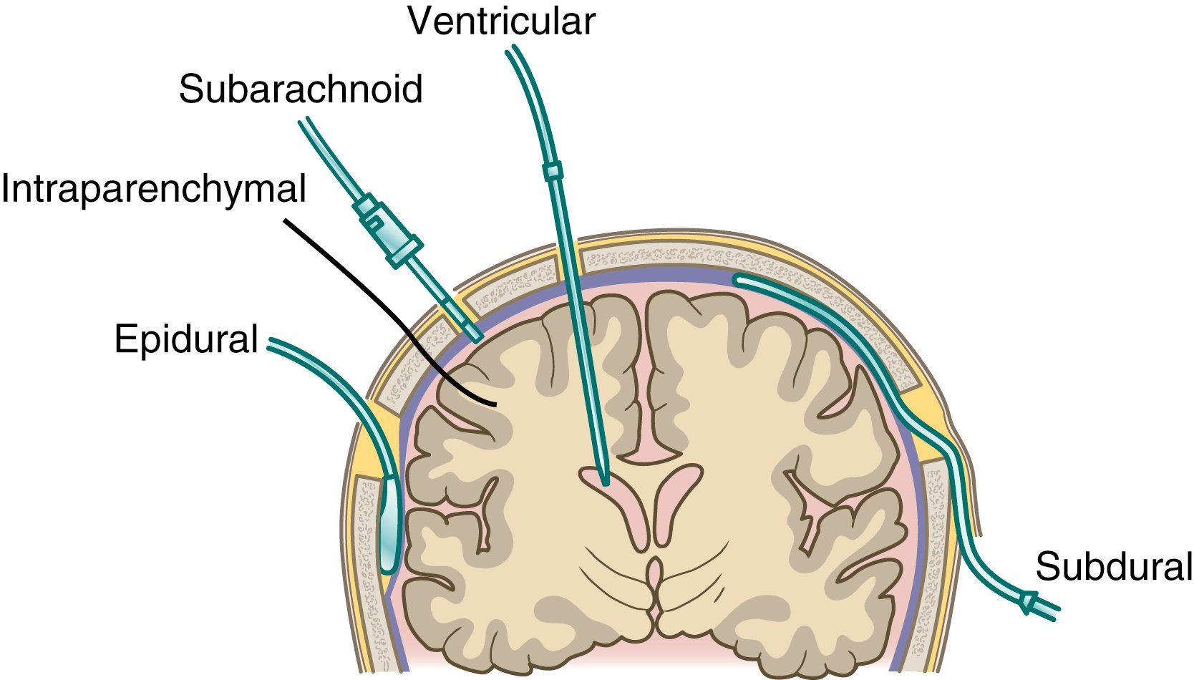FIG. 56.5 Coronal section of brain showing potential sites for placement of ICP monitoring devices.

Monitoring ICP and Cerebral Oxygenation

Indications for Intracranial Pressure Monitoring
ICP monitoring is used to guide clinical care when the patient is at risk for or has elevations in ICP.⁴ It may be used in patients with a variety of neurologic problems, including hemorrhage, stroke, tumor, infection, or traumatic brain injury (TBI). ICP should be monitored in patients admitted with a Glasgow Coma Scale (GCS) score of 8 or less and an abnormal CT scan or MRI. These results indicate that the patient may have bleeding, contusion, edema, or other problems. The GCS is discussed later on p. 1308.

Methods of Measuring ICP
Patients with conditions known to elevate ICP, except those with irreversible problems or advanced neurologic disease, usually undergo ICP monitoring in an ICU. Multiple methods and devices are available to monitor ICP in various sites (Fig. 56.5).
The gold standard for monitoring ICP is the ventriculostomy, in which a specialized catheter is inserted into the lateral ventricle and coupled to an external transducer (Figs. 56.6 and 56.7). This technique directly measures the pressure within the ventricles, facilitates removal and/or sampling of CSF, and allows for intraventricular drug administration. In this system the transducer is external. It is important to ensure that the transducer is level with the foramen of Monro (interventricular foramen). The system must also be at the ideal height (Fig. 56.8, A). A reference point for this foramen is the tragus of the ear. Every time the patient is repositioned, assess the system to ensure it is level.
The fiberoptic catheter, an alternative technology, uses a sensor transducer found within the catheter tip. The sensor tip is placed within the ventricle or the brain tissue and gives a direct measurement of brain pressure.
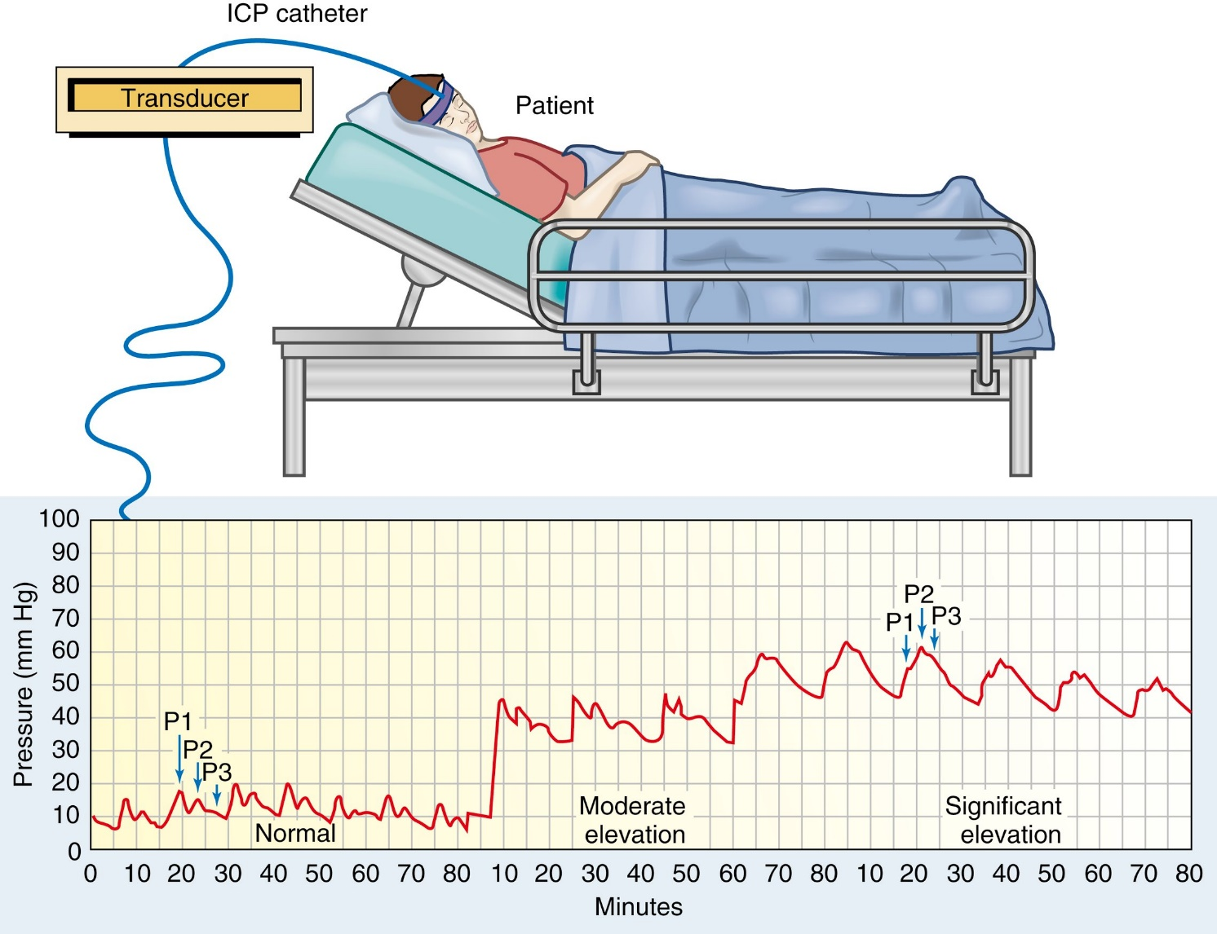FIG. 56.6 ICP monitoring can be used to continuously measure ICP. The ICP tracing shows normal, elevated, and plateau waves. At high ICP, the P2 peak is higher than the P1 peak, and the peaks become less distinct and plateau.
Modified from Copstead-Kirkhorn LC, Banasik JL: Pathophysiology, ed 5, St Louis, 2013, Mosby.
The air pouch/pneumatic technology, another system for monitoring ICP, has an air-filled pouch at the tip of the catheter that maintains a constant volume. The pressure changes within the cranium are transmitted through the changes exerted on this pouch to the monitor.
ICP is represented on the monitor as a mean pressure in millimeters of mercury (mm Hg). If a CSF drainage device is in place, the drain must be closed for at least 6 minutes to ensure an accurate reading. Record the waveform strip along with other pressure monitoring waveforms. The normal ICP waveform has 3 phases (Fig. 56.6 and Table 56.4). It is important to monitor the ICP waveform and the mean CPP. When ICP is normal, P1, P2, and P3 resemble a staircase. As ICP increases, P2 rises above P1. This indicates poor ventricular compliance (Fig. 56.6). Consider the rate at which changes occur and the patient’s clinical condition. Neurologic deterioration may not occur until ICP elevation is pronounced and sustained. Immediately report to the HCP any ICP elevation, either as a mean increase in pressure or as an abnormal waveform configuration.
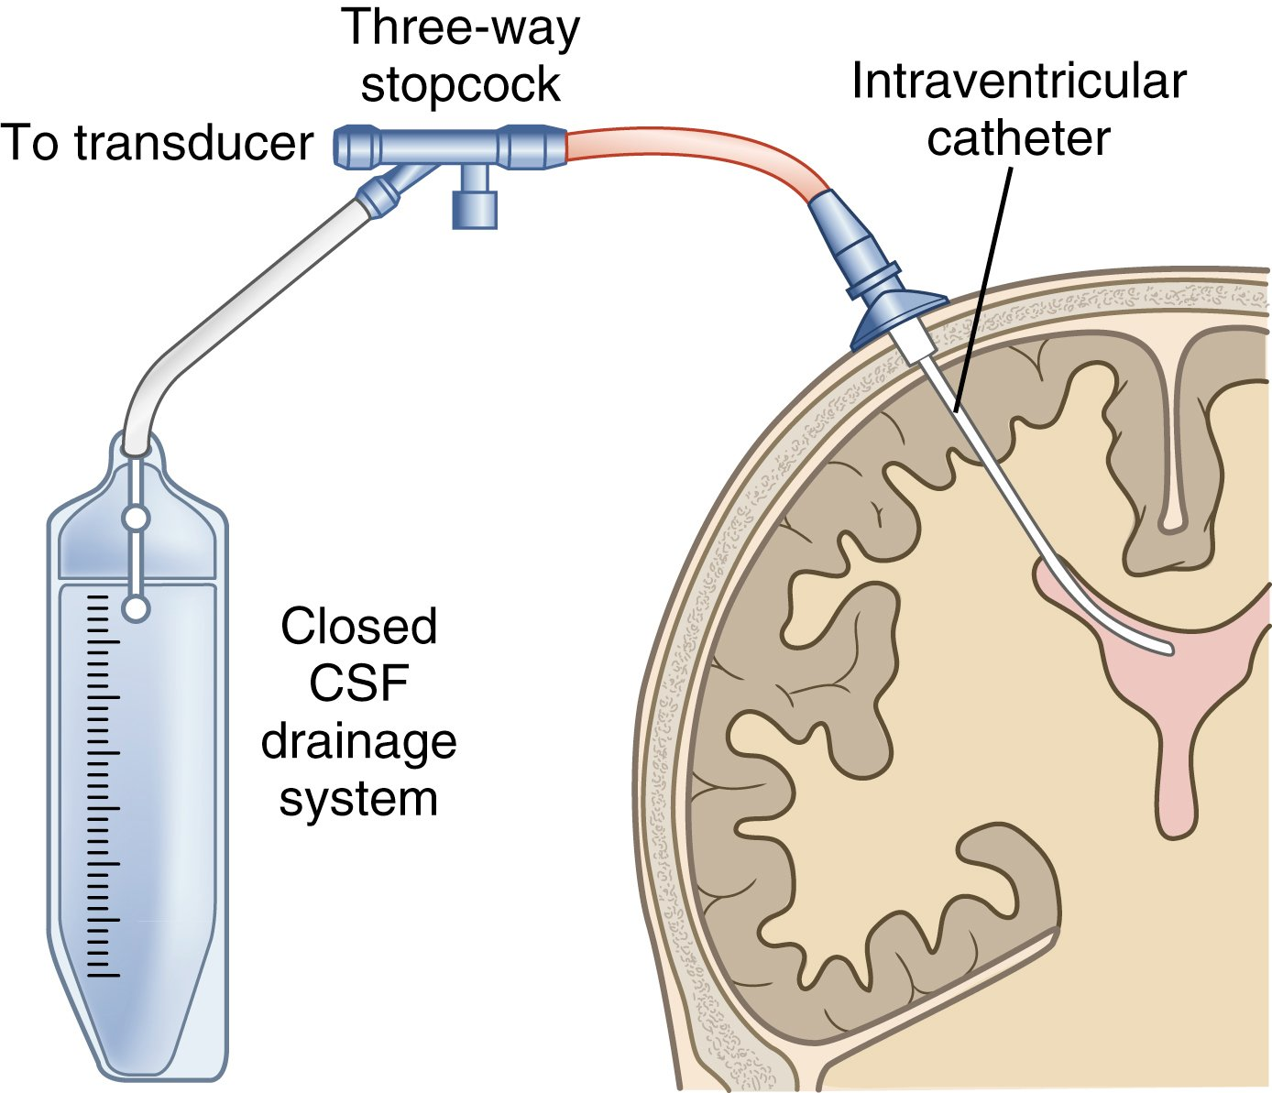FIG. 56.7 Ventriculostomy in place. Cerebrospinal fluid (CSF) can be drained via a ventriculostomy when ICP exceeds the upper pressure parameter set by the HCP. Intermittent drainage involves opening the 3-way stopcock to allow CSF to flow into the drainage bag for brief periods (30 to 120 seconds) until the pressure is below the upper pressure parameters.
Inaccurate ICP readings can be caused by CSF leaks around the monitoring device, obstruction of the intraventricular catheter (from tissue or blood clot), a difference between the height of the catheter and the transducer, kinks in the tubing, and incorrect height of the drainage system relative to the patient’s reference point. Bubbles or air in the tubing can dampen the waveform.
Infection is a serious complication with ICP monitoring. Factors that contribute to infection include ICP monitoring more than 5 days, use of a ventriculostomy, a CSF leak, and a concurrent systemic infection. Routinely assess the insertion site, use aseptic technique, and monitor the CSF for a change in drainage color or clarity.

Cerebrospinal Fluid Drainage
With the ventricular catheter, it is possible to control ICP by removing CSF (Fig. 56.7). The HCP typically orders a specific level at which to start drainage (e.g., if ICP is greater than 20 mm Hg) and the frequency of drainage (intermittent or continuous). When the ICP is above the indicated level, the system is opened by turning a stopcock and allowing the drainage of CSF, thus relieving pressure inside the cranial vault (Fig. 56.8, B). Although CSF removal decreases ICP and improves CPP, there are no universal guidelines for CSF removal. Guidelines are typically based on agency or HCP preference.⁵
The 2 options for CSF drainage are intermittent or continuous. If intermittent drainage is used, open the system at the indicated ICP and allow CSF to drain for 2 to 3 minutes. Then close the stopcock to return the ventriculostomy to a closed system. If continuous ICP drainage is ordered, carefully monitor the volume of CSF drained. Keep in mind that normal CSF production is about 20 to 30 mL/hr. There is a total CSF volume of about 150 mL within the ventricles and subarachnoid space. Post a sign above the patient’s bed to notify anyone before turning, moving, or suctioning the patient to prevent the removal of too much CSF, which can result in other complications.
TABLE 56.4 Normal Intracranial Pressure Waveforms∗
Waveform | Meaning
P1 Percussion wave | Represents arterial pulsations.  Normally the highest of the 3 waveforms.
P2 Rebound wave or tidal wave | Reflects intracranial compliance or relative brain volume.  When P2 is higher than P1, intracranial compliance is compromised.
P3 Dicrotic wave | Follows dicrotic notch.  Represents venous pulsations.  Normally the lowest waveform.
∗ See Fig. 56.6.
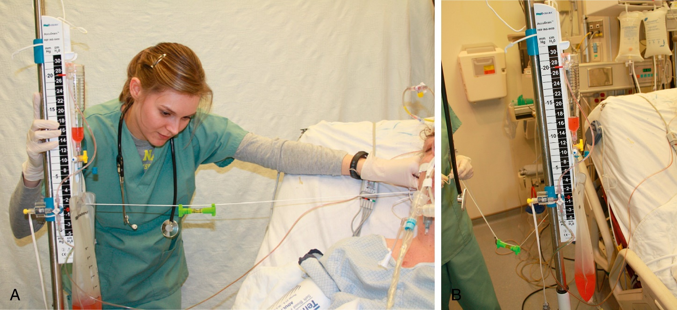FIG. 56.8 A, Leveling a ventriculostomy. B, Cerebrospinal fluid is drained into a drainage system.
Courtesy Meg Zomorodi, RN, PhD, CNL, Raleigh, NC.
Complications include ventricular collapse, infection, and herniation or subdural hematoma formation from rapid decompression. Strict aseptic technique during dressing changes or sampling of CSF is crucial to prevent infection. The system must stay intact to ensure that the ICP readings are accurate because treatment is based on the pressures.

Cerebral Oxygenation Monitoring
Technology is available to measure cerebral oxygenation and assess perfusion. Three intracranial devices used in ICU settings are the LICOX catheter, Neurovent catheter, and jugular venous bulb catheter.
The LICOX and Neurovent catheters are placed in healthy white matter of the brain (Fig. 56.9). These catheters measure brain oxygenation and temperature. These systems provide continuous monitoring of the pressure of O₂ in brain tissue (PbtO₂). The normal range for PbtO₂ is 20 to 40 mm Hg. A low PbtO₂ level indicates ischemia.² These catheters can also measure brain temperature. A cooler brain temperature (96.8° F [36° C]) may produce better outcomes.
Jugular venous bulb oximetry, which measures global O₂ extraction, is used in some agencies. The jugular venous bulb catheter is placed in the internal jugular vein and positioned so that the catheter tip is in the jugular bulb. An x-ray verifies placement. This catheter provides a measurement of jugular venous O₂ saturation (SjvO₂), which indicates total venous brain tissue extraction of O₂. This is a measure of cerebral O₂ supply and demand. The normal SjvO₂ range is 60% to 75%. Values less than 50% indicate impaired cerebral oxygenation.²
In addition to measuring ICP and brain oxygenation, many HCPs are now looking at multimodality monitoring in TBI and intracranial hypertension. This technology includes brain microdialysis (measurement of small molecules), continuous EEG, and blood flow monitoring.

Interprofessional Care
The goals of interprofessional care (Table 56.3) are to (1) identify and treat the underlying cause of increased ICP and (2) support brain function. The earlier the condition is recognized and treated, the better the patient outcome. A careful history is important in the search for the underlying cause. The underlying cause of increased ICP is usually an increase in blood (hemorrhage), brain tissue (tumor or edema), or CSF (hydrocephalus) in the brain.
For any patient with increased ICP, it is important to maintain adequate oxygenation to support brain function and prevent secondary injury. An endotracheal tube or tracheostomy may be needed to maintain adequate ventilation. Arterial blood gas (ABG) analysis guides the O₂ therapy. The goal is to maintain the PaO₂ at 100 mm Hg or greater and to keep PaCO₂ in normal range at 35 to 45 mm Hg. The patient may need to be on a mechanical ventilator to ensure adequate oxygenation.
If increased ICP is caused by a mass lesion (e.g., tumor, hematoma), surgical removal of the mass is the best treatment. See the sections on brain tumors and cranial surgery later in this chapter. In aggressive situations, a craniectomy (removal of part of skull) may be done to reduce ICP and prevent herniation.

Drug Therapy
Drug therapy plays an important part in the management of increased ICP. Mannitol (Osmitrol) (25%) is an osmotic diuretic given IV. Mannitol decreases ICP in 2 ways: plasma expansion and osmotic effect. The immediate plasma-expanding effect reduces the hematocrit and blood viscosity. This increases CBF and cerebral O₂ delivery. A vascular osmotic gradient is created by mannitol. Thus fluid moves from the tissues into the blood vessels, reducing the ICP because of the decrease in the total brain fluid content. Monitor fluid and electrolyte status when osmotic diuretics are used. Mannitol may be contraindicated if renal disease is present and serum osmolality increased.
Hypertonic saline solution is another option. It produces massive movement of water out of edematous swollen brain cells and into blood vessels. This movement can reduce swelling and improve cerebral blood flow. Care during an infusion includes frequent monitoring of BP and serum sodium levels because intravascular fluid volume excess can occur. Hypertonic saline infusion is just as effective as mannitol when treating increased ICP. They are often used concurrently when caring for a patient with a severe brain injury.⁶
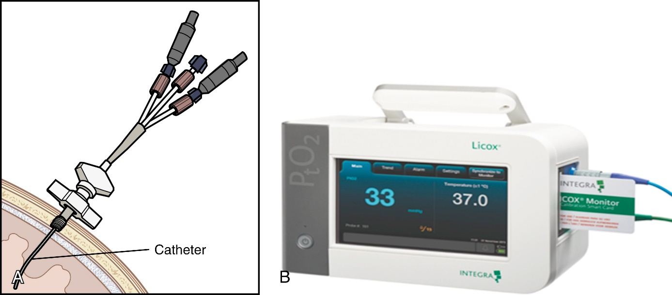FIG. 56.9 A, The LICOX brain tissue O₂ system involves insertion of a catheter. B, The system measures O₂ in the brain (PbtO₂), brain tissue temperature, and ICP.
B, Courtesy of Integra LifeSciences Corporation, Plainsboro, NJ.
Corticosteroids (e.g., dexamethasone) are used to treat vasogenic edema around tumors and abscesses. These drugs are not recommended for TBI. Corticosteroids stabilize the cell membrane and inhibit the synthesis of prostaglandins (see Fig. 11.2), preventing the formation of proinflammatory mediators. Corticosteroids also improve neuronal function by improving CBF and restoring autoregulation.
Complications associated with the use of corticosteroids include hyperglycemia, increased incidence of infections, and gastrointestinal (GI) bleeding. Regularly monitor fluid intake and sodium levels. Perform blood glucose monitoring at least every 6 hours. Patients receiving corticosteroids should receive antacid, histamine (H₂)-receptor blockers (e.g., cimetidine, ranitidine), or proton pump inhibitors (e.g., pantoprazole) to prevent GI ulcers and bleeding.
IV 0.9% sodium chloride is the preferred solution for giving secondary medications. If 5% dextrose in water or 0.45% sodium chloride is used, serum osmolarity decreases and an increase in cerebral edema may occur.
Metabolic demands, such as fever (greater than 100.4° F [38° C]), agitation or shivering, pain, and seizures, can increase ICP. Implement measures to reduce these metabolic demands to lower the ICP in the at-risk patient. Monitor patients for seizure activity. They may need prophylactic antiseizure medication. Maintain the temperature at 96.8° to 98.6° F (36° to 37° C) by using antipyretics (e.g., acetaminophen), cool baths, cooling blankets, ice packs, or intravascular cooling devices as needed. Avoid letting the patient shiver or shake, since this increases the metabolic workload on the brain. If this occurs, the patient may need sedatives or a different cooling method.
Drug therapy for reducing cerebral metabolism may be an effective way to control ICP. Reducing the metabolic rate decreases the CBF and therefore the ICP. High doses of barbiturates (e.g., pentobarbital, thiopental) are used in patients with increased ICP refractory to other treatments. Barbiturates decrease cerebral metabolism, causing a decrease in ICP and a reduction in cerebral edema. With this treatment, monitor the patient’s ICP, blood flow, and EEG. Barbiturate dosing is typically based on analysis of the bedside EEG tracing and the ICP. The HCP orders the barbiturate infusion at a rate that achieves a desired level of brain wave suppression to control ICP. Total burst suppression, recognized by the absence of spikes showing brain activity on the EEG monitor, shows that maximal therapeutic effect has been achieved.

Nutritional Therapy
Because malnutrition promotes continued cerebral edema, maintaining optimal nutrition is important. The patient with increased ICP is in a hypermetabolic and hypercatabolic state that increases the need for glucose as fuel for metabolism of the injured brain. If the patient cannot maintain an adequate oral intake, other means of meeting nutritional requirements, such as enteral feedings or parenteral nutrition, should be started.
Early feeding after brain injury may improve patient outcome.⁵ Nutritional replacement should begin within 3 days after injury and reach full nutritional replacement within 7 days after injury. The patient’s fluid and electrolyte status and metabolic needs should guide feedings or supplements. The patient should be kept in a euvolemic fluid state. Continuously evaluate the patient based on clinical factors such as urine output, insensible fluid loss, serum and urine osmolality, and serum electrolytes.

Nursing Management: Increased Intracranial Pressure

Nursing Assessment
Subjective data about the patient with increased ICP can be obtained from the patient, caregiver, or family member who is familiar with the patient. Describe the LOC by noting the specific behaviors seen. Assess the LOC using the GCS. Assess body functions, especially circulation and respiration.

Glasgow Coma Scale
The Glasgow Coma Scale (GCS) is a quick, practical, and standard system for assessing the LOC. The 3 areas assessed in the GCS are the patient’s ability to (1) open the eyes when a verbal or painful stimulus is applied, (2) speak, and (3) obey commands. Specific assessments evaluate the patient’s response to varying degrees of stimulus. Three indicators of response are evaluated: (1) opening of the eyes, (2) best verbal response, and (3) best motor response (Table 56.5).
TABLE 56.5 Glasgow Coma Scale
Appropriate Stimulus | Response | Score
Eyes Open
• Approach to bedside  • Verbal command  • Pain | Spontaneous response. | 4
• Approach to bedside  • Verbal command  • Pain | Opening of eyes to name or command. | 3
• Approach to bedside  • Verbal command  • Pain | Lack of opening of eyes to previous stimuli but opening to pain. | 2
• Approach to bedside  • Verbal command  • Pain | Lack of opening of eyes to any stimulus. | 1
• Approach to bedside  • Verbal command  • Pain | Untestable.∗ | U
Best Verbal Response
• Verbal questioning with maximum arousal | Appropriate orientation, conversant. Correct identification of self, place, year, and month. | 5
• Verbal questioning with maximum arousal | Confusion. Conversant, but disorientation in 1 or more spheres. | 4
• Verbal questioning with maximum arousal | Inappropriate or disorganized use of words (e.g., cursing), lack of sustained conversation. | 3
• Verbal questioning with maximum arousal | Incomprehensible words, sounds (e.g., moaning). | 2
• Verbal questioning with maximum arousal | Lack of sound, even with painful stimuli. | 1
• Verbal questioning with maximum arousal | Untestable.∗ | U
Best Motor Response
• Verbal command (e.g., “raise your arm, hold up 2 fingers”)  • Pain (pressure on proximal nail bed) | Obedience of command. | 6
 | Localization of pain, lack of obedience but presence of attempts to remove offending stimulus. | 5
 | Flexion withdrawal,∗ flexion of arm in response to pain without abnormal flexion posture. | 4
 | Abnormal flexion, flexing of arm at elbow and pronation, making a fist. | 3
 | Abnormal extension, extension of arm at elbow usually with adduction and internal rotation of arm at shoulder. | 2
 | Lack of response. | 1
 | Untestable.∗ | U
∗ Added to the original scale by some centers.
Specific behaviors observed as responses to the testing stimulus are given a numeric value. Your responsibility is to elicit the best response on each of the scales: the higher the scores, the higher the level of brain functioning. The subscale scores are particularly important if a patient is untestable in an area. For example, severe periorbital edema may make eye opening impossible.
The total GCS score is the sum of the numeric values assigned to each of the 3 areas. The highest GCS score is 15 for a fully alert person, and the lowest possible score is 3. A GCS score of 8 or less generally indicates coma, and mechanical ventilation should be considered. Plot the results of the GCS scores on a graph, which can be used to determine whether the patient is stable, improving, or deteriorating.
The GCS offers several advantages in the assessment of the unconscious patient. It allows different health care professionals to arrive at the same conclusion about the patient’s status. It can be used to determine between different or changing states.
Although the GCS is the gold standard assessment tool for LOC, other scales, such as the Full Outline of Unresponsiveness (FOUR) scale, are also used.⁷ In cases of stroke or hemorrhage associated with increased ICP, use the NIH Stroke Scale (see Table 57.10). Other key neurologic assessments include cranial nerve assessment and motor and sensory testing. Cranial nerve assessment is outlined in Table 55.4.

Neurologic Assessment
Compare the pupils with one another for size, shape, movement, and reactivity (Fig. 56.10). If the oculomotor nerve (CN III) is compressed, the pupil on the affected side (ipsilateral) becomes larger until it fully dilates. If ICP continues to increase, both pupils dilate.
Test pupillary reaction with a penlight. The normal reaction is brisk constriction when the light is shone directly into the eye. Note a consensual response (slight constriction in the opposite pupil) at the same time. A sluggish reaction can indicate early pressure on CN III. A fixed pupil unresponsive to light stimulus usually indicates increased ICP. However, note that there are other causes of a fixed pupil, including direct injury to CN III, previous eye surgery, atropine administration, and use of mydriatic eye drops.
In some agencies, HCPs are using a hand-held device (pupillometer) to measure the pupil reactivity and size. The device removes any subjectivity from the pupil evaluation.
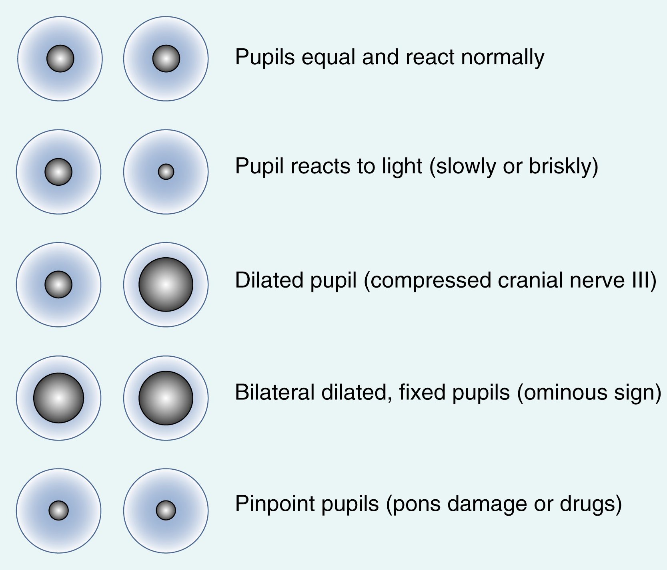FIG. 56.10 Pupillary check for size and response.
Assess eye movements controlled by CN III, CN IV, and CN VI in the patient who is awake and able to follow commands. They can be used to assess brainstem function. Testing the corneal reflex gives information about the functioning of CN V and CN VII. If this reflex is absent, start routine eye care to prevent corneal abrasion (see Chapter 20).
Eye movements of the uncooperative or unconscious patient can be elicited by reflex with the use of head movements (oculocephalic) and caloric stimulation (oculovestibular). To test the oculocephalic reflex (doll’s eye reflex), turn the patient’s head briskly to the left or right while holding the eyelids open. A normal response is movement of the eyes across the midline in the direction opposite that of the turning. Next, quickly flex and then extend the neck. Eye movement should be opposite to the direction of head movement—up when the neck is flexed and down when it is extended. Abnormal responses can help locate an intracranial lesion. This test should not be done if a cervical spine problem is suspected.
To test the oculovestibular reflex (cold caloric), the patient is positioned with the head of bed elevated. A syringe of ice-cold water is instilled into the external auditory ear canal. The patient’s eyes are assessed for a total of 1 minute. The absence of eye movement or response indicates severe neurologic demise. This test requires patent external auditory ear canals and tympanic membranes.
Test motor strength by asking the awake and cooperative patient to squeeze your hands to compare strength in the hands. The pronator drift test is an excellent measure of strength in the upper extremities. The patient raises the arms in front of the body with the palms facing upward and eyes closed. If there is any weakness in the upper extremity, the palmar surface turns downward and the arm drifts down. This would indicate a problem in the opposite motor cortex. Asking the patient to raise the foot from the bed or to bend the knees up in bed is a good assessment of lower extremity strength. Test all 4 extremities for strength and for any asymmetry in strength or movement.
Assess the motor response of the unconscious or uncooperative patient by observation of spontaneous movement. If no spontaneous movement is possible, apply a pain stimulus to the patient and note the response. Resistance to movement during passive range-of-motion exercises is another measure of strength. Do not include hand squeezing as part of the assessment of motor movement in the unconscious or uncooperative patient, since this is a reflex action and can misrepresent the patient’s status.
Record vital signs, including BP, pulse, respiratory rate, and temperature. Be aware of Cushing’s triad, which indicates severely increased ICP. Besides recording respiratory rate, note the respiratory pattern. Specific respiratory patterns are associated with severely increased ICP (Fig. 56.11).

Nursing Diagnoses
Nursing diagnoses for the patient with increased ICP include:
- • Decreased intracranial adaptive capacity
- • Ineffective tissue perfusion
- • Risk for injury
Additional information on nursing diagnoses and interventions for patients with increased ICP is presented in eNursing Care Plan 56.1 (available on the website for this chapter).

Planning
The overall goals for the patient with increased ICP are to (1) maintain a patent airway; (2) have ICP within normal limits; (3) have normal fluid, electrolyte, and nutritional balance; and (4) prevent complications from immobility and decreased LOC.
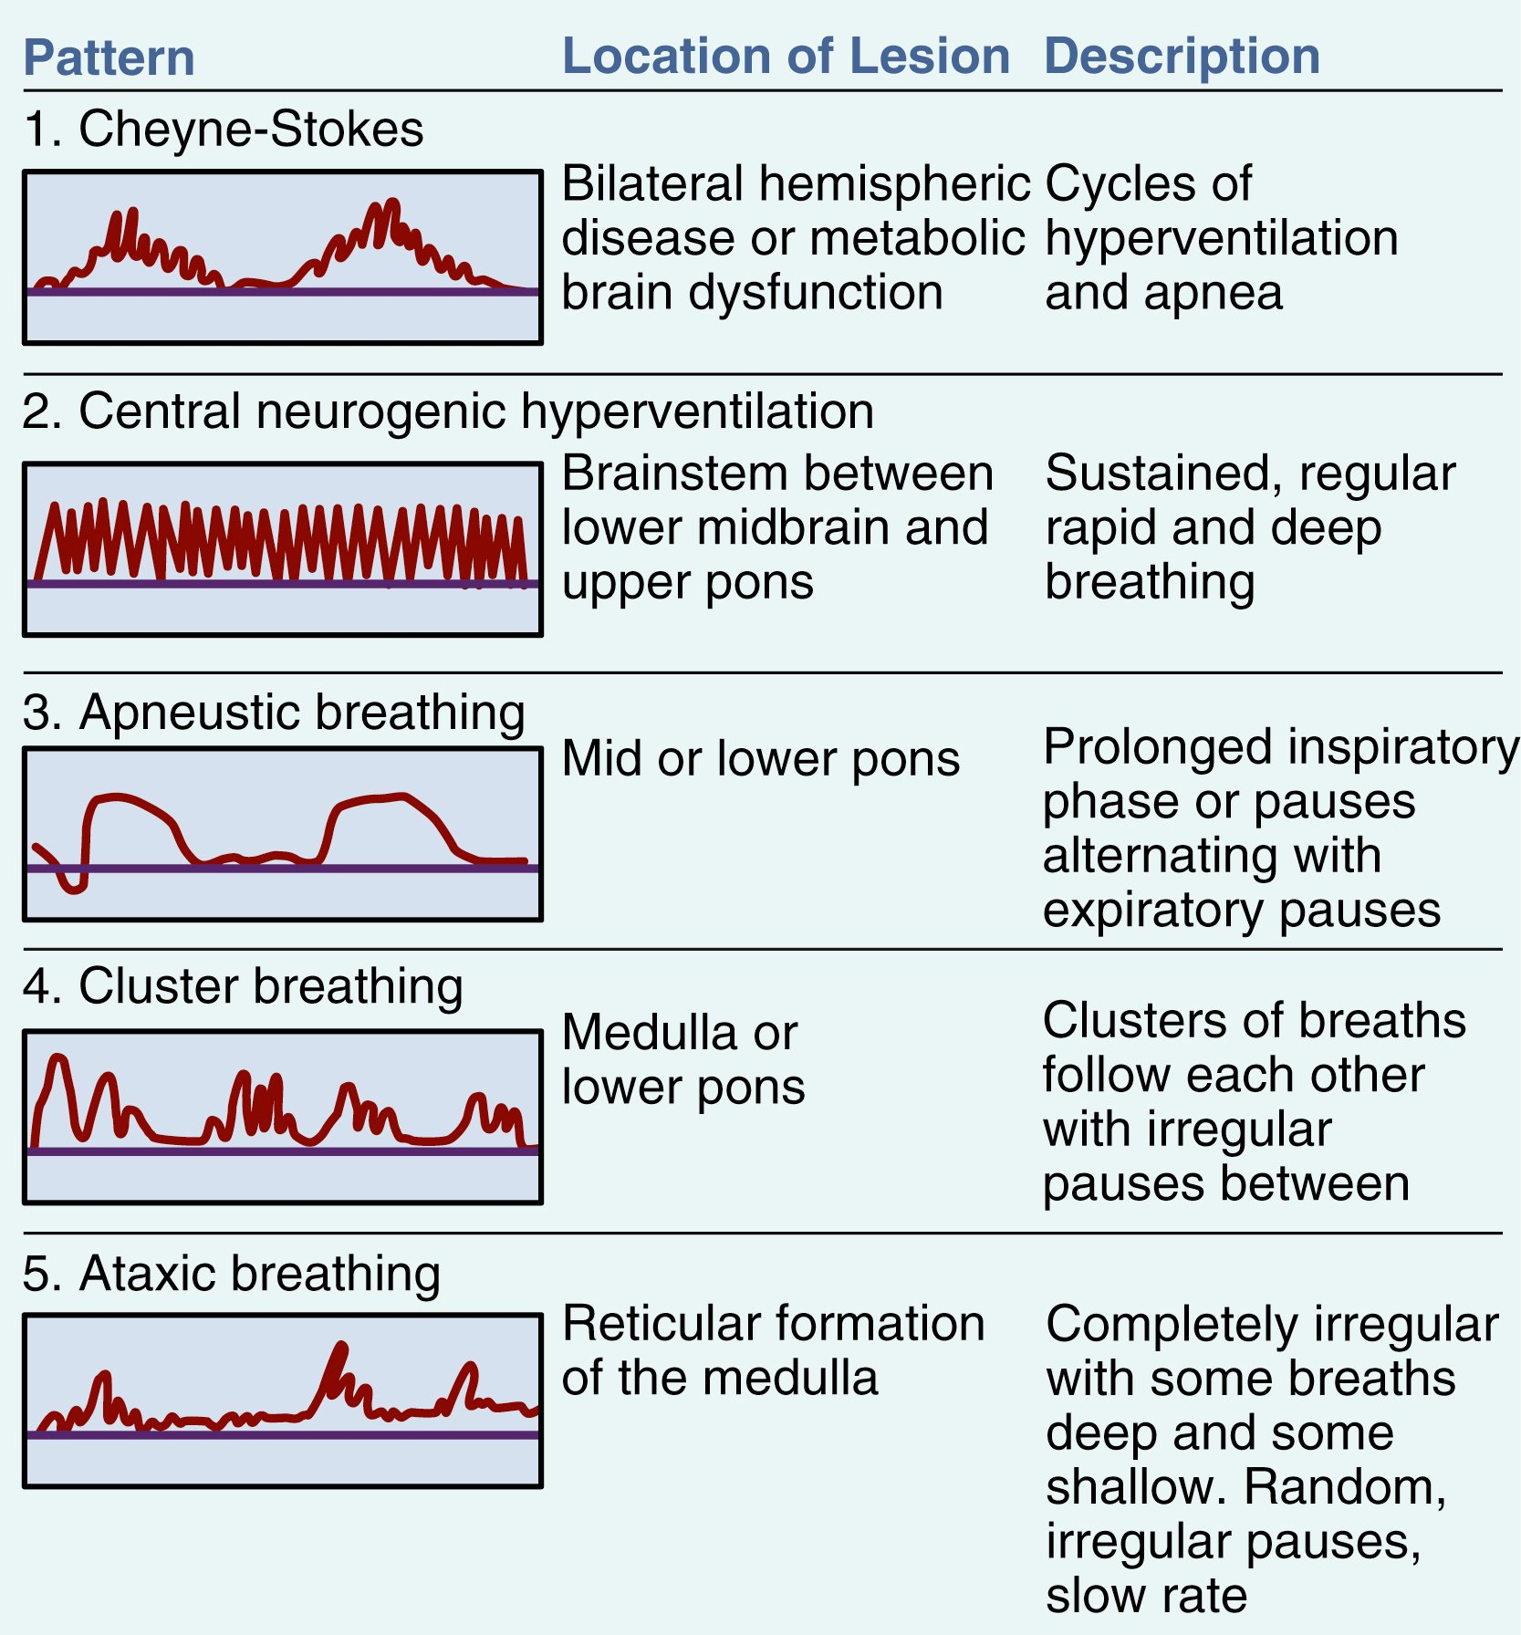FIG. 56.11 Common abnormal respiratory patterns associated with coma.

Nursing Implementation

Acute Care

Respiratory Function
Maintaining a patent airway is critical in the patient with increased ICP and is a major nursing responsibility. As the LOC decreases, the patient is at an increased risk for airway obstruction from the tongue dropping back and occluding the airway or from accumulation of secretions.
Safety Alert
Altered Breathing
- • Be alert to altered breathing patterns in a patient with increased ICP.
- • Snoring sounds indicate obstruction and require immediate intervention.
Remove accumulated secretions by suctioning as needed. An oral airway facilitates breathing and provides an easier suctioning route in the comatose patient. In general, any patient with a GCS of 8 or less or an altered LOC who is unable to maintain a patent airway or effective ventilation needs intubation and mechanical ventilation.
Frequently monitor and evaluate the ABG values. Take measures to maintain the levels within prescribed or acceptable parameters. The appropriate ventilatory support can be ordered based on the PaO₂ and PaCO₂ values.
Prevent hypoxia and hypercapnia to minimize secondary injury. Suctioning and coughing cause transient decreases in the PaO₂ and increases in the ICP. Keep suctioning to a minimum and less than 10 seconds in duration. Give 100% O₂ before and after to prevent decreases in the PaO₂. To avoid cumulative increases in the ICP with suctioning, limit suctioning to 2 passes per suction procedure, if possible. Patients with increased ICP are at risk for lower CPP during suctioning.
Try to prevent abdominal distention, since it can interfere with respiratory function. Inserting a nasogastric (NG) tube to aspirate the stomach contents can prevent distention, vomiting, and aspiration. However, in patients with facial and skull fractures, an NG tube is contraindicated due to risk for inadvertent intracranial placement. Oral insertion of a gastric tube is preferred.

Sedation
Pain, anxiety, and fear related to the primary injury, therapeutic procedures, or noxious stimuli can increase ICP and BP, thus complicating the patient’s management and recovery. The appropriate choice or combination of sedatives, paralytics, and analgesics for symptom management is a challenge. Giving these agents may alter the neurologic state, thus masking true neurologic changes. It may be necessary to temporarily stop drug therapy to appropriately assess neurologic status. The choice, dose, and combination of agents may vary depending on the patient’s history, neurologic state, and overall clinical presentation.
Opioids, such as morphine sulfate and fentanyl, are rapid-onset analgesics with minimal effect on CBF or O₂ metabolism. The IV sedative propofol (Diprivan) is used to manage anxiety and agitation in the ICU because of its rapid onset and short half-life. An accurate neurologic assessment can be done soon after stopping an infusion of propofol.
Dexmedetomidine (Precedex), an α₂-adrenergic agonist, is used for continuous IV sedation of intubated and mechanically ventilated patients in the ICU setting for up to 24 hours. When using continuous IV sedatives, be aware of the side effects of these drugs, especially hypotension, since this can lower CPP.
Nondepolarizing neuromuscular blocking agents (e.g., vecuronium, cisatracurium besylate [Nimbex]) are useful for achieving complete ventilatory control in the treatment of refractory intracranial hypertension. Because these agents paralyze muscles without blocking pain or noxious stimuli, they are used in combination with sedatives, analgesics, or benzodiazepines.
Benzodiazepines, although useful for sedation, are usually avoided in the managing the patient with increased ICP because of the hypotensive effect and long half-life. They are usually given as an adjunct to neuromuscular blocking agents.
The patient should be in a quiet, calm environment with minimal noise and interruptions. Observe the patient for signs of agitation, irritation, or frustration. Teach the caregiver and family about decreasing stimulation. Coordinate with team members to minimize procedures that may cause agitation.

Fluid and Electrolyte Balance
Fluid and electrolyte problems can have an adverse effect on ICP. Closely monitor IV fluids with the use of an accurate IV infusion control device or pump. Intake and output, accounting for insensible losses, and daily weights are important parameters in the assessment of fluid balance.
Monitor serum electrolytes, especially glucose, sodium, potassium, magnesium, and osmolality. Discuss abnormal values with the HCP.
Monitor urine output to detect problems related to diabetes insipidus and inappropriate secretion of antidiuretic hormone (SIADH). Diabetes insipidus is caused by a decrease in antidiuretic hormone (ADH). It results in increased urine output and hypernatremia. The usual treatment of diabetes insipidus is fluid replacement, vasopressin, or desmopressin acetate (DDAVP) (see Chapter 49). If it is not treated, severe dehydration will occur.
SIADH is caused by excess secretion of ADH. SIADH results in decreased urine output and dilutional hyponatremia. It may result in cerebral edema, changes in LOC, seizures, and coma. (Treatment of SIADH is described in Chapter 49.)

Monitoring ICP
ICP monitoring is used in combination with other physiologic parameters to guide the care of the patient and assess the patient’s response to treatment. Suctioning, hypoxemia, and arousal from sleep are factors that can increase ICP. Be alert to these factors and try to minimize them. Increased intrathoracic pressure can increase ICP by impeding the venous return. So, coughing, straining, sneezing, and the Valsalva maneuver should be avoided.

Body Position
Proper head positioning is important. Maintain the patient with increased ICP in the head-up position. Keep the head in a midline position, avoiding extreme neck flexion. Flexion can cause venous obstruction and contribute to increased ICP. Adjust the body position to decrease the ICP and improve the CPP. Elevating the head of the bed promotes drainage from the head and decreases the vascular congestion that can produce cerebral edema. However, raising the head of the bed above 30 degrees may decrease the CPP by lowering systemic BP. Carefully evaluate the effects of elevating the head of the bed on both ICP and CPP. Position the bed so that it lowers the ICP while optimizing the CPP and other indices of cerebral oxygenation.
Take care to turn the patient with slow, gentle movements. Rapid changes in position may increase ICP. Prevent discomfort when turning and positioning the patient because pain or agitation increases pressure. Avoid extreme hip flexion to decrease the risk for raising the intraabdominal pressure, which increases ICP. Decorticate or decerebrate posturing is a reflex response in some patients with increased ICP. Turning, skin care, and even passive range of motion can elicit these posturing reflexes.
Provide the physical care to minimize complications of immobility, such as atelectasis and contractures. Turn the patient at least every 2 hours.

Protection From Injury
The patient with increased ICP and decreased LOC needs protection from self-injury. Confusion, agitation, and the possibility of seizures increase the risk for injury. Use restraints judiciously in the agitated patient. If restraints are necessary to keep the patient from removing tubes or falling out of bed, they should be secure enough to be effective. Observe the skin area under the restraints regularly for irritation. Agitation may increase with the use of restraints, which indicates the need for other measures to protect the patient from injury. Light sedation with sedative agents may be needed. Having a family member stay with the patient may have a calming effect.
For the patient with seizures or the patient at risk for such activity, institute seizure precautions. These include padded side rails, an Ambu bag at the bedside, readily available suction, accurate and timely administration of antiseizure drugs, and close observation. Antiseizure prophylaxis against early seizures (within the first 7 to 10 days) is recommended in severe brain injury. This practice is controversial for mild to moderate brain injury.⁸
The patient can benefit from a quiet, nonstimulating environment. Always use a calm, reassuring approach. Touch and talk to the patient, even one who is in a coma.

Psychologic Considerations
In addition to carefully planned physical care, be aware of the psychologic well-being of patients and their families. Anxiety over the diagnosis and the prognosis can be distressing to the patient, caregiver and family, and nursing staff. Your competent and assured manner in performing care is reassuring to everyone involved. Short, simple explanations are appropriate and allow the patient and caregiver to acquire the amount of information they desire. There is a need for support, information, and teaching of both patients and families. Assess the family members’ desires to help with providing care for the patient and allow for their participation as appropriate. Encourage interprofessional management (e.g., social work, chaplain) involving the patient and family in decision-making as much as possible.

Evaluation
The expected outcomes are that the patient with increased ICP will
- • Maintain ICP and cerebral perfusion within normal parameters
- • Have no serious increases in ICP during or after care activities
- • Have no complications of immobility

Head Injury
Head injury includes any injury or trauma to the scalp, skull, or brain. A serious form of head injury is traumatic brain injury (TBI). Statistics about the occurrence of head injury are incomplete because many victims die at the injury scene or the condition is considered minor and health care services are not sought. An estimated 2.8 million persons are treated each year in U. S. emergency departments (EDs) for TBI. Of those, 57,000 die and 282,000 are hospitalized. Of those hospitalized, 20% will die.⁹ At least 5.3 million Americans (2% of the U.S. population) currently live with disabilities resulting from TBI.
The most common causes of head injury are falls and motor vehicle accidents. Other causes of head injury include firearms, assaults, sports-related trauma, recreational injuries, and war-related injuries.⁹ Men are twice as likely to sustain a TBI as women.
Head trauma has a high potential for a poor outcome. Deaths from head trauma occur at 3 points after injury: immediately after the injury, within 2 hours after injury, and about 3 weeks after injury.¹⁰ Most deaths occur immediately after the injury, either from the direct head trauma or from massive hemorrhage and shock. Deaths occurring within a few hours of the trauma are caused by progressive worsening of the brain injury or internal bleeding.¹¹
Deaths occurring 3 weeks or more after the injury result from multisystem failure. Expert nursing care in the weeks after the injury is crucial in decreasing the mortality risk and in optimizing patient outcomes.¹²

Types of Head Injuries

Scalp Lacerations
Scalp lacerations are an easily recognized type of external head trauma. Because the scalp contains many blood vessels with poor constrictive abilities, most scalp lacerations are associated with profuse bleeding. Even relatively small wounds can bleed significantly. The major complications associated with scalp laceration are blood loss and infection.

Skull Fractures
Skull fractures often occur with head trauma. Skull fractures are described in several ways: (1) linear or depressed; (2) simple, comminuted, or compound; and (3) closed or open (Table 56.6). Fractures may be closed or open, depending on the presence of a scalp laceration or extension of the fracture into the air sinuses or dura. The type and severity of a skull fracture depend on the velocity, momentum, direction, and shape (blunt or sharp) of the injuring agent and site of impact.
TABLE 56.6 Types of Skull Fractures
Type | Description | Cause
Comminuted | Multiple linear fractures with fragmentation of bone into many pieces | Direct, high-momentum impact
Compound | Depressed skull fracture and scalp laceration with communicating pathway to intracranial cavity | Severe head injury
Depressed | Inward indentation of skull | Powerful blow
Linear | Break in continuity of bone without change of relationship of parts | Low-velocity injuries
Simple | Linear or depressed skull fracture without fragmentation or communicating lacerations | Low to moderate impact
TABLE 56.7 Manifestations of Skull Fractures
Fracture Location | Manifestations
Basilar | CSF or brain otorrhea, bulging of tympanic membrane caused by blood or CSF, Battle’s sign, tinnitus or hearing difficulty, rhinorrhea, facial paralysis, conjugate deviation of gaze, vertigo
Frontal | Exposure of brain to contaminants through frontal air sinus, possible association with air in forehead tissue, CSF rhinorrhea, pneumocranium (air between cranium and dura mater)
Orbital | Periorbital bruising (raccoon eyes), optic nerve injury
Parietal | Deafness, CSF or brain otorrhea, bulging of tympanic membrane caused by blood or CSF, facial paralysis, loss of taste, Battle’s sign
Posterior fossa | Occipital bruising resulting in cortical blindness, visual field defects, rare appearance of ataxia or other cerebellar signs
Temporal | Boggy temporal muscle because of extravasation of blood, oval-shaped bruise behind ear in mastoid region (Battle’s sign), CSF otorrhea, middle meningeal artery disruption, epidural hematoma
The location of the fracture determines the manifestations (Table 56.7). For example, a basilar skull fracture is a specialized type of linear fracture involving the base of the skull. Manifestations can evolve over the course of several hours and vary with the location and severity of fracture. These may include cranial nerve deficits, Battle’s sign (postauricular bruising), and periorbital bruising (raccoon eyes) (Fig. 56.12). This fracture is often associated with a tear in the dura and subsequent leakage of CSF.
Rhinorrhea (CSF leakage from the nose) or otorrhea (CSF leakage from the ear) generally confirms that a fracture has traversed the dura (Fig. 56.12). Rhinorrhea may also manifest as postnasal sinus drainage. Rhinorrhea may be overlooked unless the patient is specifically assessed for this finding. The risk for meningitis is high with a CSF leak. Antibiotics should be given as a preventive measure.
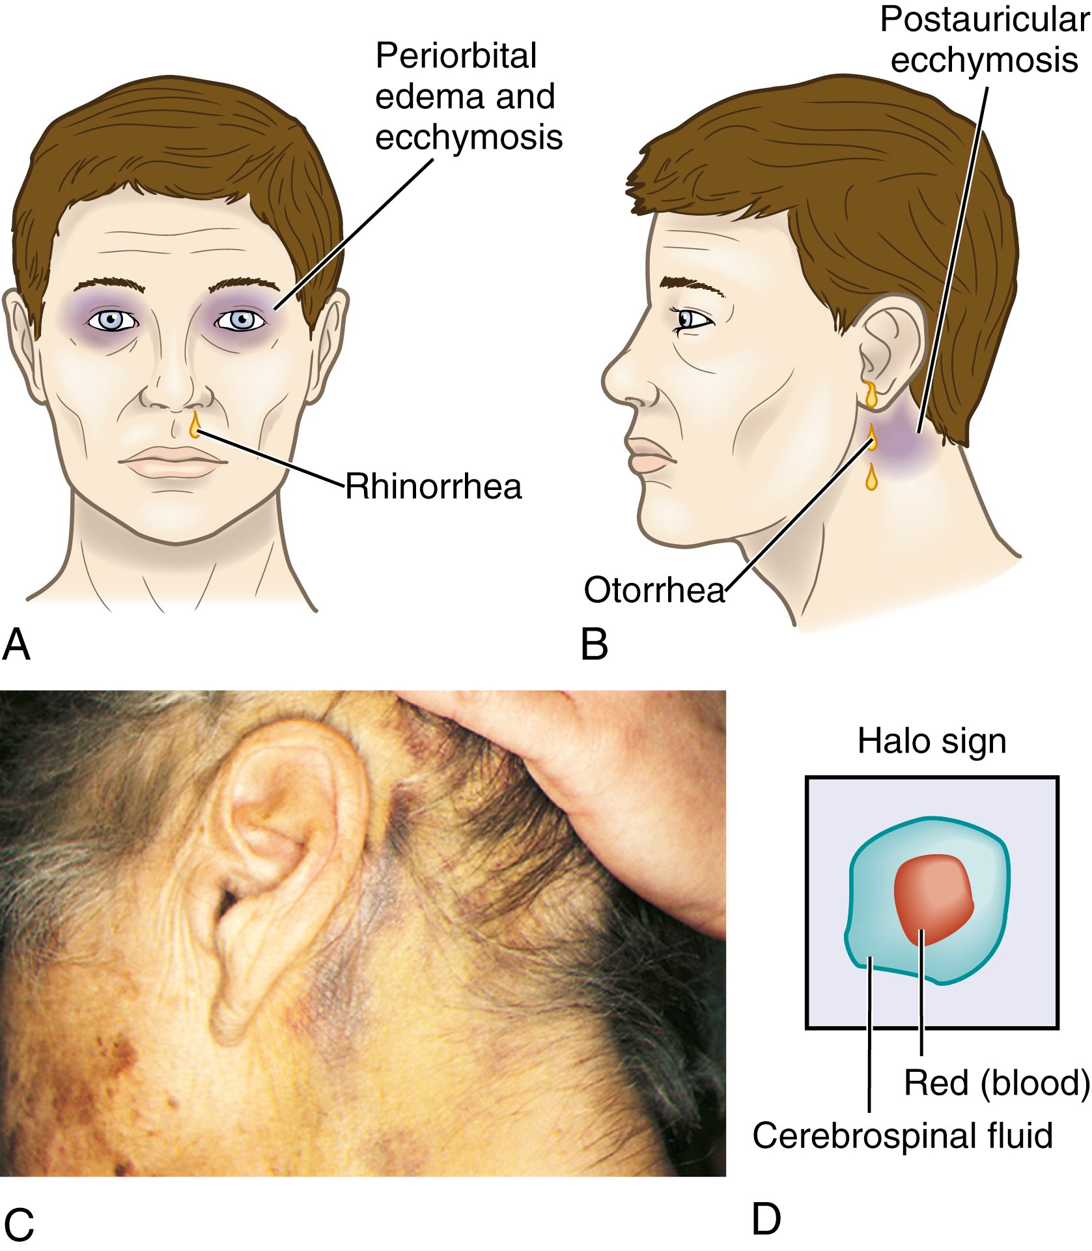FIG. 56.12 A, Raccoon eyes and rhinorrhea. B, Battle’s sign (postauricular bruising) with otorrhea. C, Battle’s sign. D, Halo or ring sign (see text).
C, From Bingham BJG, Hawke M, Kwok P: Clinical atlas of otolaryngology, St Louis, 1992, Mosby.
Two methods of testing can be used to determine whether the fluid leaking from the nose or ear is CSF. The first method is to test the leaking fluid with a Dextrostix or Tes-Tape strip to determine whether glucose is present. CSF gives a positive reading for glucose. If blood is present in the fluid, testing for glucose is unreliable because blood also contains glucose. In this event, look for the halo or ring sign (Fig. 56.12, D). Allow the leaking fluid to drip onto a white gauze pad (4 × 4) or towel, and then observe the drainage. Within a few minutes, the blood coalesces into the center, and a yellowish ring encircles the blood if CSF is present. Note the color, appearance, and amount of leaking fluid because both tests can give false-positive results.
The major complications of skull fractures are intracranial infections, hematoma, and meningeal and brain tissue damage. When a basilar skull fracture is suspected, an orogastric tube should be inserted rather than a NG tube.

Head Trauma
Brain injuries are categorized as diffuse (generalized) or focal (localized). In a diffuse injury (e.g., concussion, diffuse axonal injury), damage to the brain is not localized to one area. In a focal injury (e.g., contusion, hematoma), damage is localized to a specific area of the brain. Brain injury can be classified as minor (GCS 13 to 15), moderate (GCS 9 to 12), or severe (GCS 3 to 8).

Diffuse Injury
Concussion, a sudden transient mechanical head injury with disruption of neural activity and a change in the LOC, is considered a minor diffuse head injury. The patient may or may not lose total consciousness with this injury.
Typical signs include a brief disruption in LOC, amnesia about the event (retrograde amnesia), and headache. The manifestations are generally of short duration. If the patient has not lost consciousness, or if the loss of consciousness lasts less than 5 minutes, the patient is usually discharged with instructions to notify the HCP if symptoms persist or if behavioral changes are noted.
Postconcussion syndrome may develop in some patients, usually from 2 weeks to 2 months after the injury. Manifestations include persistent headache, lethargy, personality and behavioral changes, shortened attention span, decreased short-term memory, and changes in intellectual ability. This syndrome can significantly affect the patient’s abilities to perform activities of daily living.
Concussion is generally considered benign and usually resolves spontaneously. For some, the signs and symptoms may be the beginning of a more serious, progressive problem, especially in a patient with a history of prior concussion or head injury. At the time of discharge, it is important to give the patient and caregiver instructions for observation and accurate reporting of symptoms or changes in neurologic status.

Diffuse axonal injury
Diffuse axonal injury (DAI) is widespread axonal damage occurring after a mild, moderate, or severe TBI. The damage occurs primarily around axons in the subcortical white matter of the cerebral hemispheres, basal ganglia, thalamus, and brainstem.¹³ Initially, we thought DAI occurred because the tensile forces of trauma sheared axons, resulting in axonal disconnection. There is increasing evidence that axonal damage is not preceded by an immediate tearing of the axon from the traumatic impact. Instead, the trauma changes the function of the axon, resulting in axon swelling and disconnection. This process takes 12 to 24 hours to develop and may persist longer.
The clinical signs of DAI vary. They may include a decreased LOC, increased ICP, decortication or decerebration, and global cerebral edema. About 90% of patients with DAI stay in a persistent vegetative state.¹³ Patients with DAI who survive the initial event are rapidly triaged to an ICU. There, they will be vigilantly watched for signs of increased ICP and treated accordingly.

Focal Injury
Focal injury can be minor to severe and localized to an area of injury. Focal injury consists of lacerations, contusions, hematomas, and cranial nerve injuries.
Lacerations involve actual tearing of the brain tissue. They often occur in association with depressed and open fractures and penetrating injuries. Tissue damage is severe, and surgical repair of the laceration is impossible because of the nature of brain tissue. Medical management consists of antibiotics (until meningitis is ruled out) and preventing secondary injury related to increased ICP. If bleeding is deep into the brain tissue, focal and generalized signs develop.
With major head trauma, many delayed responses can occur. These include hemorrhage, hematoma formation, seizures, and cerebral edema. Intracerebral hemorrhage is generally associated with cerebral laceration. This hemorrhage manifests as a space-occupying lesion accompanied by unconsciousness, hemiplegia on the contralateral side, and a dilated pupil on the ipsilateral side. As the hematoma expands, signs of increased ICP become more severe. Subarachnoid hemorrhage and intraventricular hemorrhage can occur from head trauma.
A contusion is bruising of the brain tissue within a focal area. It is usually associated with a closed head injury and often occurs at a fracture site. A contusion may have areas of hemorrhage, infarction, necrosis, and edema.
With contusion, the phenomenon of coup-contrecoup injury is often noted (Fig. 56.13). Injuries can range from minor to severe. Damage from coup-contrecoup injury occurs when the brain moves inside the skull due to high-energy or high-impact injury mechanisms. Contusions or lacerations occur both at the site of the direct impact of the brain on the skull (coup) and at a second area of damage on the opposite side away from injury (contrecoup), leading to multiple contused areas. Contrecoup injuries tend to be more severe. The overall prognosis depends on the amount of bleeding around the contusion site.
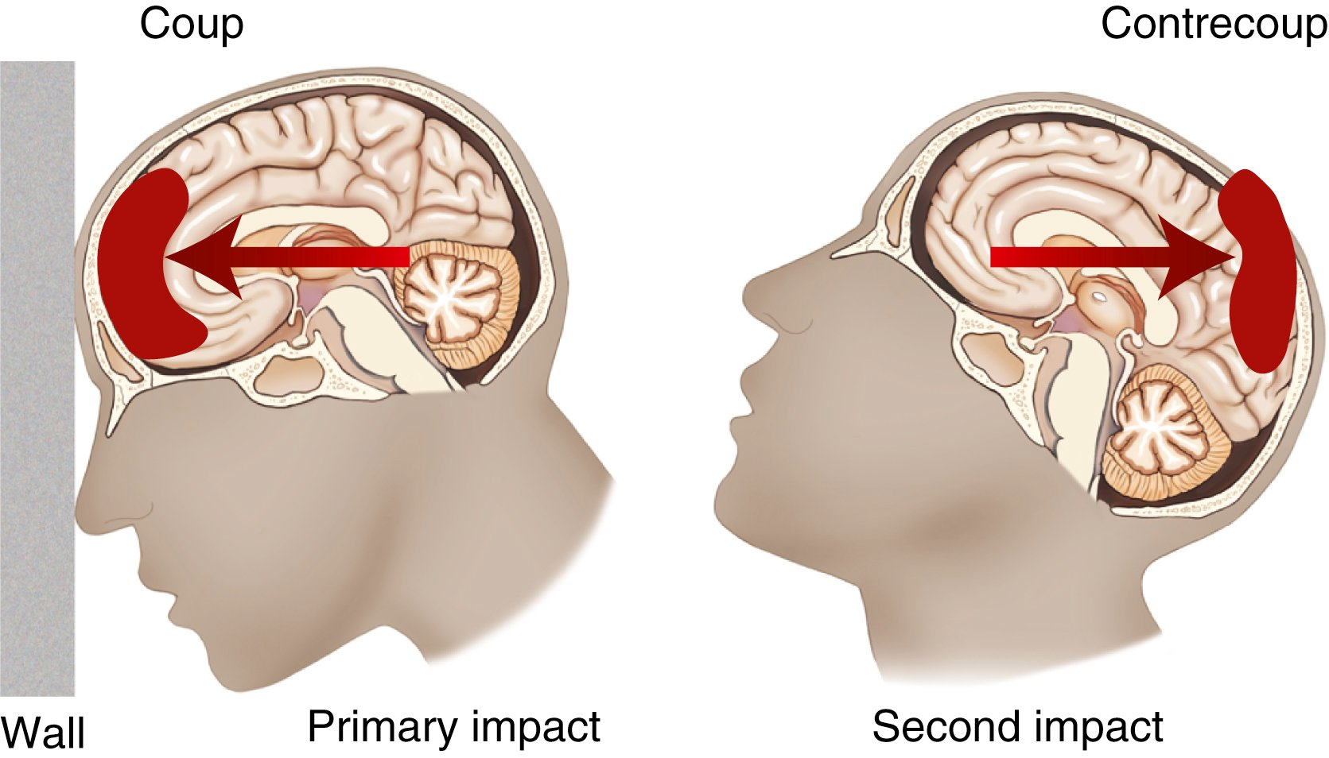FIG. 56.13 Coup-contrecoup injury. After the head strikes the wall, a coup injury occurs as the brain strikes the skull (primary impact). The contrecoup injury (the second impact) occurs when the brain strikes the skull surface opposite the site of the original impact.
Contusions may continue to bleed or rebleed and appear to “blossom” on subsequent CT scans of the brain. Bleeding worsens the neurologic outcome. Neurologic assessment may show focal and generalized manifestation, depending on the contusion’s size and location. Seizures can occur because of a brain contusion, particularly when the injury involves the frontal or temporal lobes. Anticoagulant use and coagulopathy are associated with increased hemorrhage, more severe head injury, and an increased mortality rate.¹⁴ This is especially important with older adults who are taking anticoagulants. If they fall, their contusion is likely to be more severe due to anticoagulant use. Assess for risk for falls in all patients taking anticoagulants.

Complications

Epidural Hematoma
An epidural hematoma results from bleeding between the dura and inner surface of the skull (Figs. 56.14 and 56.15). An epidural hematoma is a neurologic emergency. It is usually associated with a linear fracture crossing a major artery in the dura, causing a tear. It can have a venous or an arterial origin. Venous epidural hematomas are associated with a tear of the dural venous sinus and develop slowly. With arterial hematomas, the middle meningeal artery lying under the temporal bone is often torn. Hemorrhage occurs into the epidural space, which lies between the dura and inner surface of the skull (Fig. 56.14). Because this is an arterial hemorrhage, the hematoma develops rapidly.
Classic signs of an epidural hematoma include an initial period of unconsciousness at the scene, with a brief lucid interval followed by a decrease in LOC. Other manifestations may be a headache, nausea and vomiting, or focal findings. Rapid surgical intervention to evacuate the hematoma and prevent cerebral herniation, along with medical management for increasing ICP, dramatically improves outcomes.

Subdural Hematoma
A subdural hematoma occurs from bleeding between the dura mater and arachnoid layer of the meninges (Fig. 56.14). A subdural hematoma usually results from injury to the brain tissue and its blood vessels. The veins that drain from the surface of the brain into the sagittal sinus are the source of most subdural hematomas. Because it is usually venous in origin, a subdural hematoma may be slower to develop. However, an arterial hemorrhage can cause a subdural hematoma, in which case it develops more rapidly.
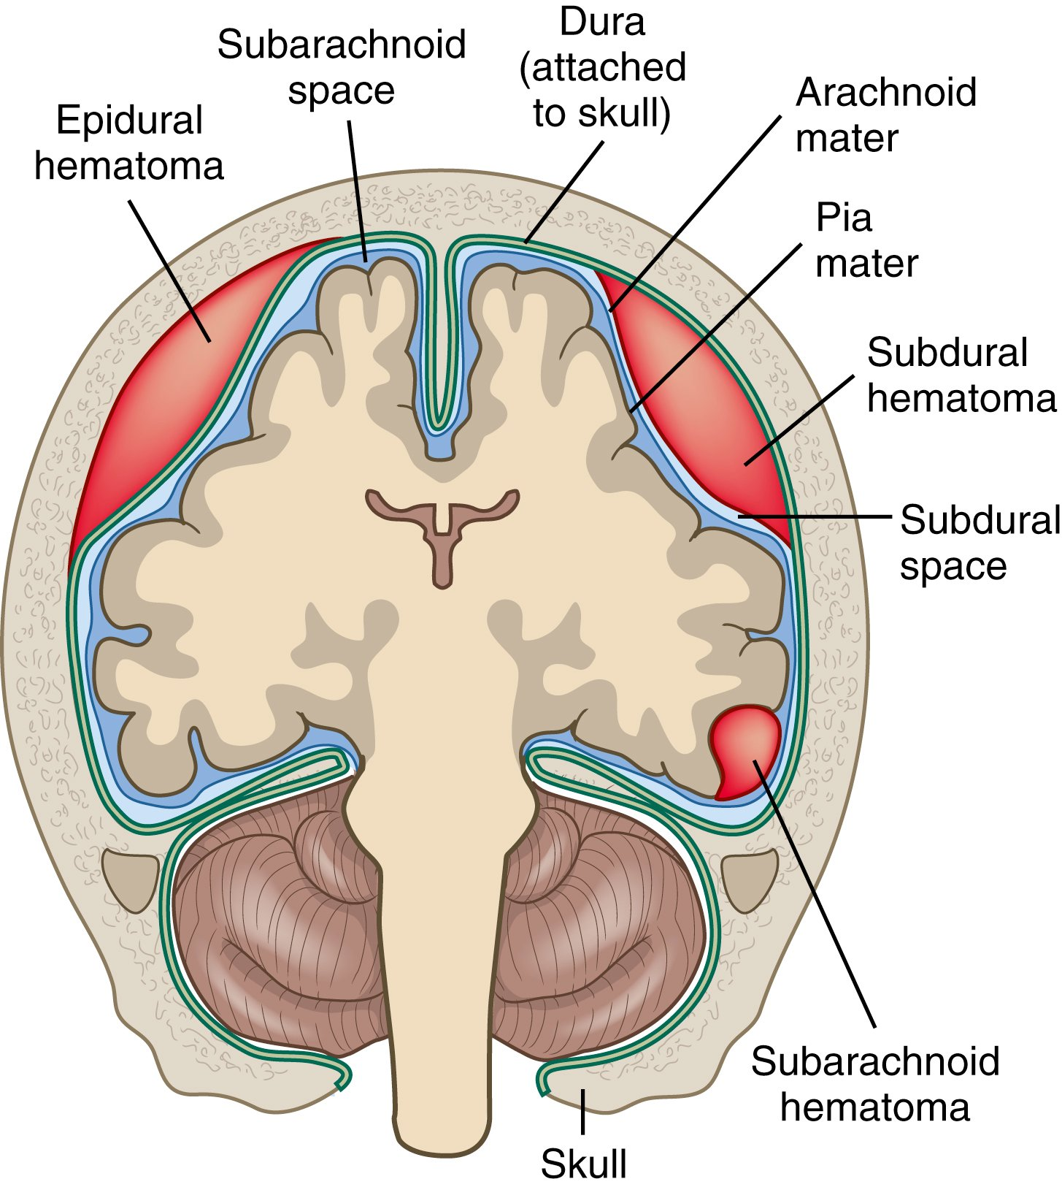FIG. 56.14 Locations of epidural, subdural, and subarachnoid hematomas.
From Copstead-Kirkhorn LC, Banasik JL: Pathophysiology, ed 4, St Louis, 2010, Mosby.
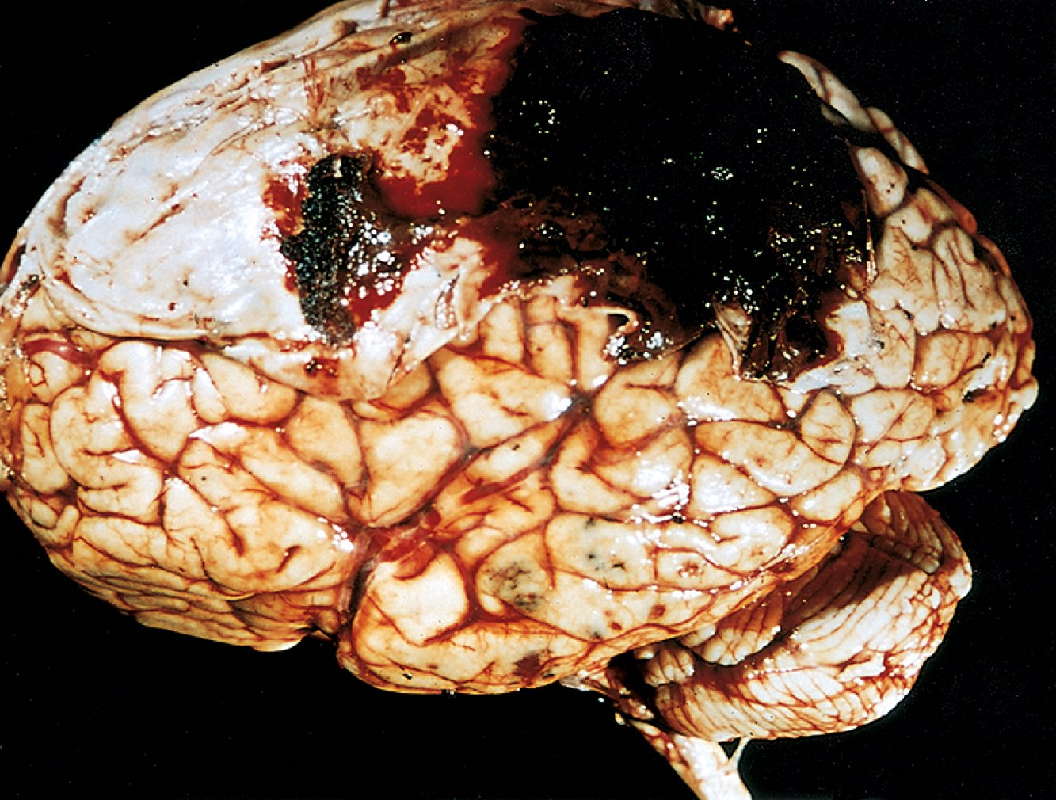FIG. 56.15 Epidural hematoma covering a portion of the dura. Multiple small contusions are seen in the temporal lobe.
From Kumar V, Abbas AK, Aster JC, et al: Robbins and Cotran pathologic basis of disease, ed 8, Philadelphia, 2010, Saunders.
Subdural hematomas may be acute, subacute, or chronic (Table 56.8). An acute subdural hematoma manifests within 24 to 48 hours of the injury.¹⁵ The signs and symptoms are similar to those associated with brain tissue compression in increased ICP. They include decreasing LOC and headache. The size of the hematoma determines the patient’s presentation and prognosis. The patient’s appearance may range from drowsy and confused to unconscious. The ipsilateral pupil dilates and becomes fixed if ICP is significantly increased. Blunt-force injuries that produce acute subdural hematomas may cause significant underlying brain injury, resulting in cerebral edema. The resulting increase in ICP from the cerebral edema can increased morbidity and mortality despite surgery to evacuate the hematoma.
TABLE 56.8 Types of Subdural Hematomas
Occurrence After Injury | Progression of Symptoms | Treatment
Acute
24–48 hr after severe trauma | Immediate deterioration | Craniotomy, evacuation, and decompression
Subacute
48 hr–2 wk after severe trauma | Decline in mental status as hematoma develops. Progression dependent on size and location of hematoma | Evacuation and decompression
Chronic
Weeks or months, usually >20 days after injury. Often injury seemed trivial or was forgotten by patient | Nonspecific, nonlocalizing progression. Progressive change in level of consciousness | Evacuation and decompression, membranectomy
A subacute subdural hematoma usually occurs within 2 to 14 days of the injury. After the initial bleeding, this hematoma may appear to enlarge over time as the breakdown products of the blood draw fluid into the subdural space.
A chronic subdural hematoma develops over weeks or months after a seemingly minor head injury.¹⁵ They are more common in older adults because of a potentially larger subdural space from brain atrophy. With atrophy, the brain stays attached to the supportive structures and tension is increased. This makes it subject to tearing. Because the subdural space is larger, the presenting problem is focal symptoms (specific to a certain area of the brain) rather than signs of increased ICP.¹⁵ Patients with a history of alcohol use are prone to subdural hematomas because of an increased incidence of falls.
Diagnosis of a subdural hematoma in the older adult may be delayed because symptoms mimic other health problems in this age-group, such as somnolence, confusion, lethargy, and memory loss. The manifestations of a subdural hematoma are often attributed to vascular disease (stroke, transient ischemic attack [TIA]) or dementia.
Check Your Practice
You are doing BP screenings in the senior center when you meet a 76-yr-old man and his wife. As you perform their BP screening, the wife tells you that her husband has been getting severe headaches, is dizzy, and sometimes has difficulty talking. Based on your advice, they go to an urgent care center, where a CT scan is done. The results show he has a chronic subdural hematoma. When you find out the diagnosis, you are puzzled because you thought he was having a stroke and cannot understand how he got a subdural hematoma.
- • If you had been the nurse, what would you have done differently when screening this man?

Intracerebral Hematoma
Intracerebral hematoma occurs from bleeding within the brain tissue. It occurs in about 16% of head injuries. It usually happens in the frontal and temporal lobes, possibly from rupture of intracerebral vessels at the time of injury. The size and location of the hematoma are key in determining the patient’s outcome.
TABLE 56.9 Emergency ManagementHead Injury
Etiology | Assessment Findings | Interventions
Blunt  • Assault  • Fall  • Motor vehicle collision  • Sports injury  Penetrating  • Arrow  • Gunshot  • Knife | Surface Findings  • Bruises or contusions on face, Battle’s sign (bruising behind ears)  • Fracture or depressions in skull  • Raccoon eyes (dependent bruising around eyes)  • Scalp lacerations  Central Nervous System  • Asymmetric facial movements  • Combativeness  • Confusion  • CSF leaking from ears or nose  • Decerebrate or decorticate posturing  • Decreased level of consciousness  • Depressed or hyperactive reflexes  • Dilated or unequal pupils, photophobia  • Flaccidity  • Garbled speech, abusive speech  • GCS score <12  • Incontinence  • Involuntary movements  • Seizures  Respiratory  • Central neurogenic hyperventilation  • Cheyne-Stokes respirations  • Decreased O₂ saturation  • Pulmonary edema | Initial  • If unresponsive, assess circulation, airway, and breathing.  • If responsive, monitor airway, breathing, and circulation.  • Assume neck injury with head injury.  • Stabilize cervical spine.  • Apply O₂ via nonrebreather mask.  • Establish IV access with 2 large-bore catheters to infuse normal saline or lactated Ringer’s solution.  • Intubate if GCS score <8.  • Control external bleeding with sterile pressure dressing.  • Remove patient’s clothing.  Ongoing Monitoring  • Maintain normothermia using blankets, warm IV fluids, as needed.  • Monitor vital signs, level of consciousness, O₂ saturation, cardiac rhythm, GCS score, pupil size and reactivity.  • Expect intubation if gag reflex is impaired or absent.  • Assess for rhinorrhea, otorrhea, scalp wounds.  • Give fluids cautiously to prevent fluid overload and increasing ICP.

Diagnostic Studies and Interprofessional Care
In general, the diagnostic studies are similar to those used for a patient with increased ICP (Table 56.3). CT scan is the best diagnostic test to evaluate for head trauma. It allows for rapid diagnosis and intervention in the acute care setting. MRI, PET, and evoked potential studies may be used to diagnose head injuries. An MRI scan is more sensitive than the CT scan in detecting small lesions. Transcranial Doppler studies allow for the measurement of cerebral blood flow (CBF) velocity. A cervical spine x-ray series, CT scan, or MRI of the spine may be done since cervical spine trauma often occurs at the same time as a head injury.
Emergency management of the patient with a head injury is outlined in Table 56.9. The principal treatment of head injuries is prompt diagnosis and surgery (if needed), In addition, we institute measures to prevent secondary injury by treating cerebral edema and managing increased ICP. For the patient with concussion and contusion, observation and management of increased ICP are the main management strategies.
The treatment of skull fractures is usually conservative. For depressed fractures and fractures with loose fragments, a craniotomy is done to elevate the depressed bone and remove the free fragments. If large amounts of bone are destroyed, the bone may be removed (craniectomy) and a cranioplasty will be needed later (see pp. 1321–1322).
In cases of large acute subdural and epidural hematomas or those associated with significant neurologic impairment, the blood must be removed through surgical evacuation. A craniotomy is generally done to see and allow control of the bleeding vessels. Burr-hole openings may be used in an extreme emergency for a more rapid decompression, followed by a craniotomy. A drain may be placed after surgery for several days to prevent blood from reaccumulating. In cases in which extreme swelling is expected (e.g., DAI, hemorrhage), a craniectomy may be done. This involves removing a piece of skull to reduce the pressure inside the cranial vault. It reduces the risk for herniation.

Nursing Management: Head Injury

Nursing Assessment
A patient with a head injury always has the potential to develop increased ICP, which is associated with higher mortality rates and poorer functional outcomes. Objective data are obtained by applying the GCS (Table 56.5), assessing and monitoring the neurologic status, and determining whether a CSF leak has occurred. Nursing assessment related to increased ICP is discussed on pp. 1308–1309. Nursing assessment of the patient with a head injury is outlined in Table 56.10.

Nursing Diagnoses
Nursing diagnoses for the patient who has sustained a head injury may include:
- • Decreased intracranial adaptive capacity
- • Ineffective tissue perfusion
- • Hyperthermia
- • Risk for injury
- • Anxiety

Planning
The overall goals are that the patient with an acute head injury will (1) maintain adequate cerebral oxygenation and perfusion; (2) stay afebrile; (3) be free of discomfort; (4) be free from infection; (5) have adequate nutrition; and (6) attain maximal cognitive, motor, and sensory function.
TABLE 56.10 Nursing AssessmentHead Injury
Subjective Data
Important Health Information
- Past health history: Mechanism of injury: motor vehicle collision, sports injury, industrial incident, assault, falls
- Medications: Anticoagulant drugs
Functional Health Patterns
- Health perception–health management: Alcohol or recreational drugs. Risk-taking behaviors
- Cognitive-perceptual: Headache, mood or behavioral change, mentation changes, aphasia, dysphasia, impaired judgment
- Coping–stress tolerance: Fear, denial, anger, aggression, depression
Objective Data
General
- Altered mental status
Integumentary
- Lacerations, contusions, abrasions, hematoma, Battle’s sign, periorbital edema and bruising, otorrhea, exposed brain matter
Respiratory
- Rhinorrhea, impaired gag reflex, inability to maintain a patent airway. Impending herniation: altered/irregular respiratory rate and pattern
Cardiovascular
- Impending herniation: Cushing’s triad (systolic hypertension with widening pulse pressure, bradycardia with full and bounding pulse, irregular respirations)
Gastrointestinal
- Vomiting, projectile vomiting, bowel incontinence
Urinary
- Bladder incontinence
Reproductive
- Uninhibited sexual expression
Neurologic
- Altered level of consciousness, seizure activity, pupil dysfunction, cranial nerve deficit(s)
Musculoskeletal
- Motor deficit/impairment, weakness, palmar drift, paralysis, spasticity, decorticate or decerebrate posturing, muscular rigidity or increased tone, flaccidity, ataxia
Possible Diagnostic Findings
- Location and type of hematoma, edema, skull fracture, and/or foreign body on CT scan and/or MRI; abnormal EEG; positive toxicology screen or alcohol level, ↓ or ↑ blood glucose level; ↑ ICP

Nursing Implementation

Health Promotion
One of the best ways to prevent head injuries is to prevent car and motorcycle accidents. Be active in campaigns that promote driving safety. Speak to driver education classes about the dangers of distracted driving and driving after drinking alcohol or using drugs. Helmets for motorcycle riders is the most effective measure for increasing survival after crashes.
Ethical/Legal Dilemmas
Brain Death
Situation
The emergency nurse receives a call from emergency response system (ERS) personnel, who are in route with R.G., a young man involved in a motorcycle crash. He was not wearing a helmet and has a large open skull fracture. Transport from the accident scene was delayed by 45 min because of a severe thunderstorm and traffic congestion. R.G. has fixed, dilated pupils and is in cardiac arrest. Estimated arrival at the hospital is still another 45 min because of the severe weather. EMS personnel request permission to stop resuscitation efforts.
Ethical/Legal Points for Consideration
- • Criteria for brain death include coma or unresponsiveness, absence of brainstem reflexes, and apnea (see Chapter 9).
- • The definition of death has changed with the advent of new technology, monitoring devices, and interventions.
- • In a situation in which the professional responsible for determining a state of death is in remote contact with the patient, but the monitoring devices available provide virtual contact with the patient, a remote diagnosis of death may be legally acceptable.
- • Brain death criteria do not address patients in a permanent vegetative state since the brainstem activity in these patients is adequate to maintain heart and lung function.
- • CPR is not appropriate when survival is not expected or the patient is expected to survive without the ability to communicate. Quantitative futility implies that survival is not expected after CPR under given circumstances. In the absence of mitigating factors, prolonged resuscitative efforts are unlikely to be successful and can be stopped if there is no return of spontaneous circulation at any time during 30 minutes of cumulative advanced life support.
- • It is ethical for ED personnel to stop treatment started by ERS personnel in the prehospital setting if there is valid, after-the-fact evidence that these interventions are now inappropriate.
Discussion Questions
- • What are your feelings about cessation of brain function vs. cessation of heart and lung function as the criteria for death of a patient?
- • What are your state’s laws or practices about stopping CPR efforts by ERS personnel in the field?
Promoting Population Health
Reducing the Risk for Head Injuries
- • Always wear car seat belts in motor vehicles.
- • Do not drive after using drugs or alcohol.
- • Do not text and drive or drive distracted.
- • Wear helmets while bicycling, skating, skateboarding, skiing, and playing contact sports.
- • Athletes should follow safe playing techniques and the rules of the game.
- • Assess home safety and implement any corrective measures needed.
- • Older adults should continue to exercise regularly to improve strength and balance.
- • Follow workplace safety precautions, including wearing helmets and protective gear.

Acute Care
Management at the injury scene can have a significant impact on the outcome of a head injury. Emergency management of head injury is outlined in Table 56.9. The general goal of nursing management of the patient with head injury is to maintain cerebral oxygenation and perfusion and prevent secondary cerebral ischemia.
TABLE 56.11 Patient & Caregiver TeachingHead Injury
Include the following instructions when teaching the patient and caregiver about care during the first 2 or 3 days after a head injury:
- 1. Notify your HCP immediately if you have signs and symptoms that may indicate complications. These include:

  - • Increased drowsiness (e.g., difficulty arousing, confusion)
  - • Nausea or vomiting
  - • Worsening headache or stiff neck
  - • Seizures
  - • Vision difficulties (e.g., blurring) or sensitivity to light (photophobia)
  - • Behavioral changes (e.g., irritability, anger)
  - • Motor problems (e.g., clumsiness, difficulty walking, slurred speech, weakness in arms or legs)
  - • Sensory problems (e.g., numbness)
  - • A heart rate <60 beats/min
- 2. Have someone stay with you.
- 3. Abstain from alcohol.
- 4. Check with your HCP before taking drugs that may increase drowsiness, including muscle relaxants, tranquilizers, and opioid analgesia.
- 5. Avoid driving, using heavy machinery, playing contact sports, and taking hot baths.
Surveillance or monitoring for changes in neurologic status is critically important because the patient’s condition may deteriorate rapidly, requiring emergency surgery. Appropriate nursing interventions are started if surgery is anticipated. Because of the close association between hemodynamic status and cerebral perfusion, be aware of any coexisting injuries or conditions.
Explain the need for frequent neurologic assessments to both the patient and caregiver. Behavioral manifestations associated with head injury can result in a frightened, disoriented patient who is combative and resists help. Your approach should be calm and gentle. A family member may be available to stay with the patient and thus decrease anxiety and fear. An important need of the caregiver and family members in the acute injury phase is information about the patient’s diagnosis, treatment plan, and reason for the interventions. Other teaching points are described in Table 56.11.
Perform neurologic assessments at intervals based on the patient’s condition. The GCS is useful in assessing the LOC (Table 56.5). Report any signs of a deteriorating neurologic state, no matter how subtle, such as a decreasing LOC or decreasing motor strength, to the HCP. Monitor the patient’s condition closely.
The major focus of nursing care for the patient with a brain injury relates to increased ICP (see eNursing Care Plan 56.1). However, some problems need specific nursing intervention.
Eye problems may include loss of the corneal reflex, periorbital bruising and edema, and diplopia. Loss of the corneal reflex may require lubricating eye drops or taping the eyes shut to prevent abrasion. Periorbital bruising and edema decrease with time. Cold and, later, warm compresses provide comfort and hasten the process. Wearing an eye patch can relieve diplopia. Consider a consult with an ophthalmologist.
Fever may occur from injury to or inflammation of the hypothalamus. Fever can cause increased CBF, cerebral blood volume, and ICP. Increased metabolism from fever increases metabolic waste, which in turn causes further cerebral vasodilation. Avoid fever with a goal of a temperature of 96.8° to 98.6° F (36° to 37° C) as the standard of care. Use interventions to reduce temperature as previously discussed (see p. 1308) in conjunction with sedation to prevent shivering.
If CSF rhinorrhea or otorrhea occurs, inform the HCP at once. The head of the bed may be raised to decrease the CSF pressure so that a tear can seal. A loose collection pad may be placed under the nose or over the ear. Do not place a dressing in the nasal or ear cavities. Document the amount of drainage each shift. Teach the patient not to sneeze or blow the nose. Do not use NG tubes. Do not perform nasotracheal suctioning on these patients because of the high risk for meningitis.
Nursing measures specific to the care of the immobilized patient, such as those related to bladder and bowel function, skin care, and infection, are needed. Nausea and vomiting may be a problem and can be alleviated by antiemetic drugs. Headache can usually be controlled with acetaminophen or small doses of codeine.
If the patient’s condition deteriorates, intracranial surgery may be needed (see the section on cranial surgery on pp. 1321–1323). A burr-hole opening or craniotomy may be done, depending on the underlying injury that is causing the problems. The emergency nature of the surgery may hasten the usual preoperative preparation. Consult with the HCP to determine specific preoperative nursing measures.
The patient is often unconscious before surgery, making it necessary for a family member to sign the consent form for surgery. This is a difficult and frightening time for the patient’s caregiver and family and requires sensitive nursing management. The suddenness of the situation makes it especially hard for the family to cope. Use a team approach, including social workers, to help the patient and family throughout the hospitalization and recovery time.

Ambulatory Care
Once the condition has stabilized, the patient is usually transferred for acute rehabilitation management. There may be chronic problems related to motor and sensory deficits, communication, memory, and intellectual functioning. Conditions that may need nursing and interprofessional management include nutrition problems, bowel and bladder problems, spasticity, dysphagia, and hydrocephalus. Many of the principles for managing the patient with a stroke are appropriate for these patients (see Chapter 57).
Seizure disorders may occur in patients with nonpenetrating head injury. Seizures may develop during the first week after the head injury or not until years later. Antiseizure drugs may be used prophylactically to manage posttraumatic seizure activity, but this practice is controversial.
The mental and emotional sequelae are often the most incapacitating problems. One of the consequences of TBI is that the person may not realize that a brain injury has occurred. Many patients with head injuries who were comatose for more than 6 hours undergo some personality change. They may have loss of concentration and memory and defective memory processing. Personal drive may decrease. Apathy may increase. Euphoria and mood swings, along with a seeming lack of awareness of the seriousness of the injury, may occur. The patient’s behavior may indicate a loss of social restraint, judgment, tact, and emotional control.
Progressive recovery may continue for years. Specific nursing management in the posttraumatic phase depends on specific residual deficits. Being able to return to work and maintaining employment is one of the challenges during the recovery period.¹⁶ The patient’s outward physical appearance does not necessarily reflect what has happened in the brain. It is not a good indicator of how well the patient will ultimately function in the home or work environment.
TABLE 56.12 Types of Brain Tumors
Type | Tissue of Origin | Characteristics
Acoustic neuroma (schwannoma) | Cells that form myelin sheath around nerves. Often affects cranial nerve VIII | Many grow on both sides of the brain. Usually benign or low-grade.
Gliomas
• Astrocytoma | Supportive tissue, glial cells, and astrocytes | Can range from low-grade to moderate-grade.
• Ependymoma | Ependymal epithelium | Range from benign to highly malignant. Most are benign and encapsulated.
• Glioblastoma | Primitive stem cell (glioblast) | Highly malignant and invasive. Among the most devastating of primary brain tumors.
• Medulloblastoma | Primitive neuroectodermal cell | Highly malignant and invasive. Metastatic to spinal cord and remote areas of brain.
• Oligodendroglioma | Oligodendrocytes | Benign (encapsulation and calcification).
Hemangioblastoma | Blood vessels of brain | Rare and benign. Surgery is curative.
Meningioma | Meninges | Can be benign or malignant. Most are benign.
Metastatic tumors | Lungs and breast (most common) | Malignant.
Pituitary adenoma | Pituitary gland | Usually benign.
Primary central nervous system lymphoma | Lymphocytes | Increased incidence in transplant recipients and acquired immunodeficiency syndrome (AIDS) patients.
Give the family special consideration. They need to understand what is happening. Provide guidance and referrals for financial aid, child care, and other personal needs. Help the family in involving the patient in family activities whenever possible. Help the patient and family remain hopeful. The family often has unrealistic expectations of the patient as the coma begins to recede. The family expects full return to pretrauma status. In reality, the patient usually has a reduced awareness and ability to interpret environmental stimuli. Prepare the family for the patient’s emergence from coma and explain that the process of awakening often takes several weeks. In addition, arrange for social work and chaplain consultations for the family.
When it is the time for discharge planning, the patient, caregiver, and family may benefit from specific instructions to avoid family-patient friction. Special “no” policies that may be suggested by the HCP, neuropsychologist, and nurse include no drinking of alcoholic beverages, no driving, no use of firearms, no working with hazardous implements and machinery, and no unsupervised smoking. Family members, particularly spouses, go through role transition as the role changes from that of spouse to that of caregiver.

Evaluation
The expected outcomes are that the patient with a head injury will
- • Maintain normal CPP
- • Achieve maximal cognitive, motor, and sensory function
- • Have no infection or fever

Brain Tumors
There are an estimated 23,400 people diagnosed each year with brain tumors in the United States. The brain is also a frequent site for metastasis from other sites.¹⁷ Males have a slightly higher incidence of brain tumors than females. Brain tumors most often occur in middle-aged persons, but they may be seen at any age.
Promoting Health Equity
Brain Tumors
- • Whites have a higher incidence of malignant brain tumors than blacks.
- • White males have the highest incidence of malignant brain tumors.
- • Blacks have the highest incidence of benign brain tumors (e.g., meningiomas).

Types
Brain tumors can occur in any part of the brain or spinal cord. Tumors of the brain may be primary, arising from tissues within the brain, or secondary, resulting from a metastasis of cancer from elsewhere in the body.¹⁸
Metastatic brain tumors are the most common brain tumor. The cancers that most often metastasize to the brain are lung and breast.
Primary brain tumors are generally classified according to the tissue from which they arise (Table 56.12). Meningiomas are the most common primary brain tumor. Other common brain tumors are gliomas (e.g., astrocytoma, glioblastoma [most common form of glioma]).
More than half of brain tumors are malignant. They infiltrate the brain tissue and are not amenable to complete surgical removal. Other tumors may be histologically benign but are located such that complete removal is not possible.
Brain tumors rarely metastasize outside the central nervous system (CNS) because they are contained by structural (meninges) and physiologic (blood-brain) barriers. Table 56.12 compares the most common brain tumors. A glioblastoma and meningioma are shown in Fig. 56.16.

Clinical Manifestations and Complications
The manifestations of brain tumors depend mainly on their location and size (Table 56.13). A wide range of manifestations are possible. Headache is common. Tumor-related headaches tend to be worse at night and may awaken the patient. The headaches are usually dull and constant but sometimes throbbing. Seizures are common in gliomas and brain metastases. Brain tumors can cause nausea and vomiting from increased ICP. Cognitive dysfunction, including memory problems and mood or personality changes, is common, especially in patients with brain metastases. Muscle weakness, sensory losses, aphasia, and visual-spatial dysfunction may occur.
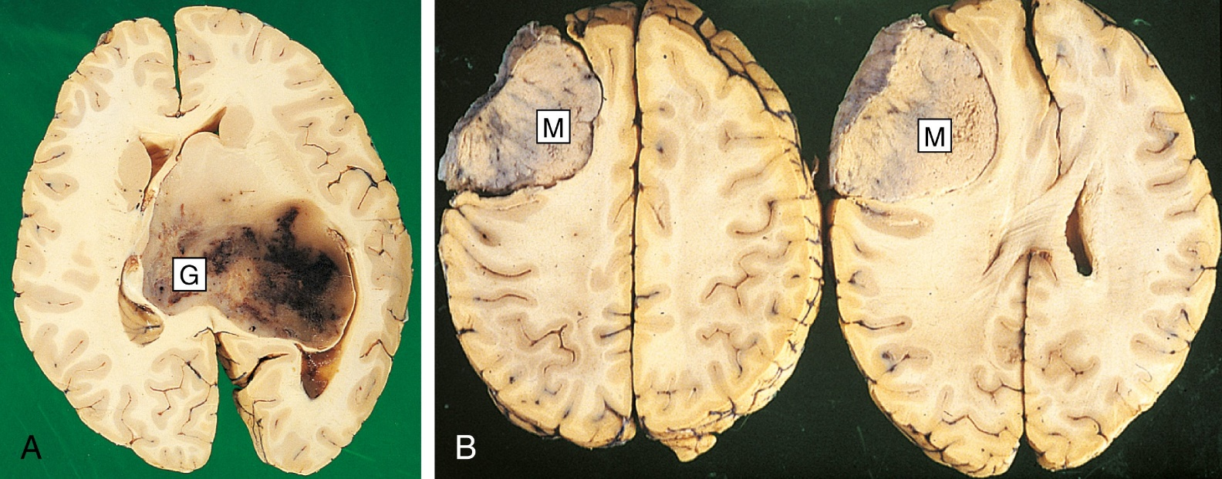FIG. 56.16 A, A large glioblastoma (G) arises from one cerebral hemisphere and has grown to fill the ventricular system. B, Meningioma. These 2 different sections from different levels in the same brain show a meningioma (M) compressing the frontal lobe and distorting underlying brain.
From Stevens A, Lowe J: Pathology: Illustrated review in colour, ed 2, London, 2000, Mosby.
TABLE 56.13 Manifestations of Brain Tumors
Tumor Location | Manifestations
Brainstem tumors | Headache on awakening, drowsiness, vomiting, ataxic gait, facial muscle weakness, hearing loss, dysphagia, dysarthria, “crossed eyes” or other visual changes, hemiparesis
Cerebellopontine tumors | Tinnitus and vertigo, deafness
Cerebral hemisphere
• Frontal lobe (unilateral) | Unilateral hemiplegia, seizures, memory deficit, personality and judgment changes, visual changes
• Frontal lobe (bilateral) | Symptoms associated with unilateral frontal lobe tumors. Ataxic gait
• Parietal lobe | Speech problems (if tumor is in the dominant hemisphere), inability to write, spatial disorders, unilateral neglect
• Occipital lobe | Vision changes and seizures
• Temporal lobe | Few symptoms. Seizures, dysphagia, hallucinations, auras
Fourth ventricle and cerebellar tumors | Headache, nausea, and papilledema (occur from ↑ ICP). Ataxic gait and changes in coordination
Meningeal tumors | Symptoms associated with compression of the brain and depend on tumor location
Metastatic tumors | Headache, nausea, or vomiting (occur from ↑ ICP). Other symptoms depend on tumor location
Subcortical | Hemiplegia; other symptoms may depend on area of infiltration
Thalamus and sellar tumors | Headache, nausea, vision changes, papilledema, and nystagmus (occur from ↑ ICP). Diabetes insipidus may occur
If the tumor mass obstructs the ventricles or occludes the outlet, ventricular enlargement (hydrocephalus) can occur. As the brain tumor expands, it may produce manifestations of increased ICP, cerebral edema, or obstruction of the CSF pathways. Unless treated, all brain tumors eventually cause death from increasing tumor volume leading to increased ICP.

Diagnostic Studies
An extensive history and a comprehensive neurologic examination is done in the workup of a patient with a suspected brain tumor. The history and physical examination may provide data with respect to location. New onset of seizures or adult-onset migraines may indicate a brain tumor and should be investigated. Diagnostic studies are similar to those used for a patient with increased ICP (Table 56.3).
The sensitivity of techniques such as MRI and PET scans allows for detection of small tumors and may provide more reliable diagnostic information than a CT scan. CT with contrast and MRI are used to identify the lesion’s location. Other tests include magnetic resonance spectroscopy, functional MRI (fMRI), and single-photon emission computed tomography (SPECT). An EEG can rule out seizures but is of less importance. An LP is seldom diagnostic and carries with it the risk for cerebral herniation. Cerebral angiography can determine blood flow to the tumor and further localize the tumor. Other studies are done to rule out a primary lesion elsewhere in the body. Endocrine studies are helpful when a pituitary adenoma is suspected (see Chapter 49).
The correct diagnosis of a brain tumor can be made by obtaining tissue for histologic study. In most patients, tissue is obtained at the time of surgery. Computer-guided stereotactic biopsy is also an option. A smear or frozen section can be done in the operating room for a preliminary interpretation of the histologic type. With this information, the HCP can make a better decision about the extent of surgery.

Interprofessional Care
Treatment goals are aimed at (1) identifying the tumor type and location, (2) removing or decreasing tumor mass, and (3) preventing or managing increased ICP.

Surgical Therapy
Surgical removal is the preferred treatment for brain tumors. Stereotactic surgical techniques are used with greater frequency to perform a biopsy and remove small brain tumors. The outcome of surgery depends on the tumor’s type, size, and location. Meningiomas and oligodendrogliomas can usually be completely removed. The more invasive gliomas and medulloblastomas may only be partially removed. Computer-guided stereotactic biopsy, ultrasound, fMRI, and cortical mapping can localize brain tumors during surgery.
Complete surgical removal of brain tumors is not always possible because the tumor is not always accessible or may involve vital parts of the brain. Surgery can reduce tumor mass, which decreases ICP, provides relief of symptoms, and extends survival time.

Ventricular Shunts
Hydrocephalus due to a tumor obstructing the CSF flow can be treated with the placement of a ventricular shunt. A catheter with 1-way valves is placed in the lateral ventricle and then tunneled under the skin to drain CSF into the peritoneal cavity. Rapid decompression of ICP can cause total body collapse and weakness. Headache may be prevented by gradually introducing the patient to the upright position.
Manifestations of shunt malfunction, which are related to increased ICP, include decreasing LOC, restlessness, headache, blurred vision, or vomiting. This may require shunt revision or replacement. Infection may occur, as exhibited by high fever, persistent headache, and stiff neck. Antibiotics are used to treat the infection. In some situations, the shunt must be replaced. CSF drainage is managed with an extraventricular drainage system while the infection is treated.

Radiation Therapy and Stereotactic Radiosurgery
Radiation therapy may be used as a follow-up measure after surgery. Radiation seeds can be implanted into the brain. Cerebral edema and rapidly increasing ICP may be a complication of radiation therapy. These problems can usually be managed with high doses of corticosteroids (e.g., dexamethasone, methylprednisolone). Radiation therapy is discussed in Chapter 15.
Stereotactic radiosurgery is a method of delivering a highly concentrated dose of radiation to a precise location within the brain. Stereotactic radiosurgery may be used when conventional surgery has failed or is not an option because of the tumor location. (Radiosurgery is discussed on p. 1322.)

Chemotherapy and Targeted Therapy
The effectiveness of chemotherapy has been limited by the difficulty with getting drugs across the blood-brain barrier, tumor cell heterogeneity, and tumor cell drug resistance. Chemotherapy drugs called nitrosoureas (e.g., carmustine, lomustine) are used to treat brain tumors. Normally the blood-brain barrier prohibits the entry of most drugs into the brain. Cancer tumors can cause a breakdown of the blood-brain barrier in the area of the tumor, thus allowing chemotherapy agents to be used to treat the cancer. Chemotherapy-laden biodegradable wafers (e.g., Gliadel wafer [polifeprosan with carmustine implant]) implanted at the time of surgery can deliver chemotherapy directly to the tumor site. Other drugs being used include methotrexate and procarbazine (Matulane). One way used to deliver chemotherapy drugs directly to the CNS is intrathecal administration via an Ommaya reservoir.
Temozolomide (Temodar) is an oral chemotherapy agent that can cross the blood-brain barrier. In contrast with many chemotherapy drugs, which require metabolic activation to exert their effects, temozolomide can convert spontaneously to a reactive agent that directly interferes with tumor growth. It does not interact with other common drugs taken by patients with brain tumors, such as antiseizure drugs, corticosteroids, and antiemetics.
Drug Alert
Temozolomide (Temodar)
- • Causes myelosuppression. Before using, the absolute neutrophil count should be ≥1500/μL and platelet count should be ≥100,000/μL.
- • To reduce nausea and vomiting, take on empty stomach or at bedtime.
Bevacizumab (Avastin) is used to treat patients with glioblastoma that continues to progress after standard therapy. Bevacizumab is a targeted therapy that inhibits the action of vascular endothelial growth factor, which helps form new blood vessels. These vessels can feed a tumor, helping it to grow, and provide a pathway for cancer cells to circulate in the body. Targeted therapy is discussed in Chapter 15 and Table 15.13.

Other Therapies
A medical device system, the Optune System, is used to treat glioblastoma that recurs or progresses after receiving chemotherapy and radiation therapy. With this system, electrodes are placed on the surface of the patient’s scalp to deliver low-intensity, changing electrical fields called tumor treatment fields (TTFs) to the tumor site.

Nursing Management: Brain Tumors

Nursing Assessment
Interview data are as important as the actual physical assessment. Ask about the medical history, intellectual abilities and educational level, and history of nervous system infections and trauma. Structure the initial assessment to provide baseline data of the patient’s neurologic status. Use this information to design a realistic, patient specific care plan.
Assess the patient’s LOC, motor abilities, sensory perception, integrated function (including bowel and bladder function), and balance and proprioception. Determine the presence of seizures, syncope, nausea and vomiting, and headaches or other pain. Assess the coping abilities of the patient, caregiver, and family. Watching a patient perform activities of daily living and listening to the patient’s conversation can be part of the neurologic assessment. Having the patient or caregiver explain the problem can be helpful to determine the patient’s limitations and obtain information about the patient’s insight into the problems. Record all initial data to provide a baseline for comparison to determine whether the patient’s condition is improving or deteriorating.

Nursing Diagnoses
Nursing diagnoses for the patient with a brain tumor may include:
- • Ineffective tissue perfusion
- • Acute pain
- • Anxiety
- • Risk for injury

Planning
The overall goals are that the patient with a brain tumor will (1) maintain normal ICP, (2) maximize neurologic functioning, (3) achieve control of pain and discomfort, and (4) be aware of the long-term implications with respect to prognosis and cognitive and physical functioning.

Nursing Implementation
A tumor of the frontal lobe can cause behavioral and personality changes. Loss of emotional control, confusion, disorientation, memory loss, impulsivity, and depression may be signs of a frontal lobe lesion. The patient often does not perceive these changes. They can be disturbing and frightening to the caregiver and family. These changes can also cause a distancing to occur between the family and patient. Help the caregiver and family understand what is happening to the patient and support the family.
The confused patient with behavioral instability can be a challenge. Protecting the patient from self-harm is an important part of nursing care. Essential interventions include close supervision of activity, use of side rails, judicious use of restraints, appropriate sedatives, padding of the rails and the area around the bed, and a calm, reassuring approach.
Perceptual problems associated with frontal and parietal lobe tumors contribute to a patient’s disorientation and confusion. Minimize environmental stimuli, create a routine, and use reality orientation for the confused patient. Tumors in the temporal lobe can cause hallucinations, which may be confused with dementia or delirium.
Seizures, which often occur with brain tumors, are managed with antiseizure drugs. Use seizure precautions for the patient’s protection. Some behavioral changes seen in the patient are a result of seizure disorders and can improve with adequate seizure control. Patients at risk for seizures may be unable to drive, so be aware of the extra resources needed and collaborate with the social worker and family. Seizure disorders are discussed in Chapter 58.
Motor and sensory dysfunctions interfere with activities of daily living. Encourage the patient to provide as much self-care as physically possible. Self-image often depends on the patient’s ability to take part in care within the limitations of the physical deficits.
Language deficits may be present. Motor (expressive) or sensory (receptive) dysphasia may occur. The problem with communication can be frustrating for the patient and may interfere with your ability to meet the patient’s needs. Try to establish a communication system that both the patient and staff can use.
Nutritional intake may be decreased because of the patient’s inability to eat, loss of appetite, or loss of desire to eat. Assess nutritional status and ensure adequate nutritional intake. Encourage the patient to eat. Some patients may need enteral or parenteral nutrition (see Chapter 39).
Provide help and support during the adjustment phase and in long-range planning. Social work and home health nurses may be needed to aid the caregiver with discharge planning and to help the family adjust to role changes and psychosocial and socioeconomic factors. Issues related to palliative and end-of-life care must be discussed with both the patient and family (see Chapter 9).

Evaluation
The expected outcomes are that the patient with a brain tumor will
- • Achieve control of pain, vomiting, and other discomforts
- • Maintain ICP within normal limits
- • Have maximal neurologic function given the location and extent of the tumor
- • Maintain optimal nutritional status
- • Accept the long-term consequences of the tumor and its treatment

Cranial Surgery
Indications for cranial surgery are related to brain tumors, CNS infection (e.g., abscess), vascular abnormalities, craniocerebral trauma, seizure disorder, or intractable pain (Table 56.14).

Types
Various types of cranial surgical procedures are outlined in Table 56.15.
TABLE 56.14 Indications for Cranial Surgery
Indication | Cause | Surgical Procedure
Aneurysm repair | Dilation of weak area in arterial wall (usually near anterior portion of circle of Willis) | Dissection and clipping or coiling of aneurysm
Arteriovenous (AV) malformation | Congenital tangle of arteries and veins (often in middle cerebral artery) | Excision of malformation
Brain abscess | Bacteria that caused intracranial infection | Excision or drainage of abscess
Brain tumors | Benign or malignant cell growth | Excision or partial resection of tumor
Hydrocephalus | Overproduction of cerebrospinal fluid, obstruction to flow, defective reabsorption | Placement of ventriculoperitoneal or (rarely) ventriculoatrial shunt
Intracranial bleeding | Rupture of cerebral vessels because of trauma or stroke | Surgical evacuation through burr holes or craniotomy
Skull fractures | Trauma to skull | Debridement of fragments and necrotic tissue, elevation and realignment of bone fragments
TABLE 56.15 Types of Cranial Surgery
Type | Description
Burr hole | Opening into the cranium with a drill. Used to remove localized fluid and blood beneath the dura.
Craniectomy | Excision into the cranium to cut away bone flap.
Cranioplasty | Repair of cranial defect resulting from trauma, malformation, or previous surgical procedure. Artificial material used to replace damaged or lost bone.
Craniotomy | Opening into cranium with removal of bone flap and opening the dura to remove a lesion, repair a damaged area, drain blood, or relieve ↑ ICP.
Shunt procedures | Alternative pathway to redirect cerebrospinal fluid from one area to another using a tube or implanted device. Examples include ventricular shunt and Ommaya reservoir.
Stereotactic procedure | Precise localization of a specific area of the brain using a frame or frameless system based on 3-dimensional coordinates. Used for biopsy, radiosurgery, or dissection.

Craniotomy
Depending on the location of the pathologic condition, a craniotomy may be frontal, parietal, occipital, temporal, suboccipital, or a combination of any of these. The HCP drills a set of burr holes and uses a saw to connect the holes to remove the bone flap (Fig. 56.17). Sometimes operating microscopes are used to magnify the site. After surgery, the bone flap is secured with small plates or wired shut. Sometimes drains are placed to remove fluid and blood. Patients are usually cared for in an ICU until stable.
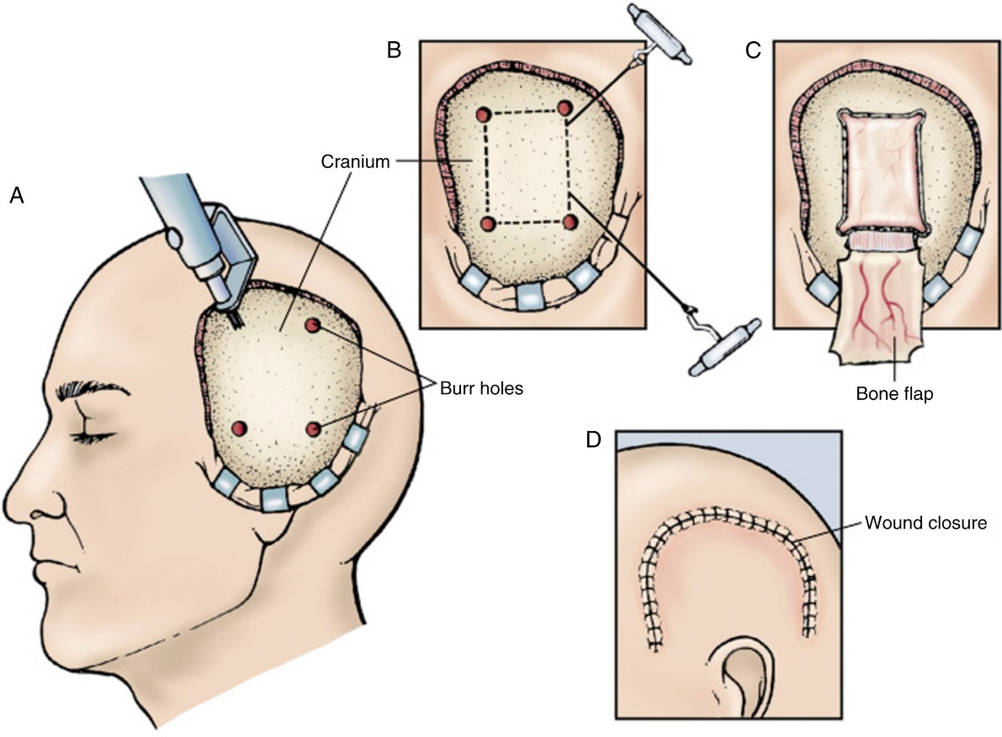FIG. 56.17 Craniotomy. A, Burr holes are drill into skull. B, Skull is cut between burr holes with a surgical saw. C, Bone flap is turned back to expose cranial contents. D, Bone flap is replaced and wound closed.
From Monahan F, Sands J, Neighbors M, et al: Phipps’ medical-surgical nursing: Health and illness perspectives, ed 9, St Louis, 2007, Mosby.

Stereotactic Radiosurgery
Stereotactic procedures use a precision apparatus (often computer guided) to help the HCP precisely target an area of the brain. Stereotactic biopsy can be done to obtain tissue samples for histologic examination. CT scanning and MRI are used to image the targeted tissue. With the patient under general or local anesthesia, the HCP drills a burr hole or creates a bone flap for an entry site and then introduces a probe and biopsy needle. Stereotactic procedures are used for removal of small brain tumors and abscesses, drainage of hematomas, ablative procedures for extrapyramidal diseases (e.g., Parkinson’s disease), and repair of arteriovenous malformations. A major advantage of the stereotactic approach is a reduction in damage to surrounding tissue.
Stereotactic radiosurgery is not a form of surgery in the traditional sense. Instead, radiosurgery uses precisely focused radiation to destroy tumor cells and other abnormal growths in the brain. Computers create 3-dimensional images of the brain. These images are used to guide the focused radiation while the patient’s head is held still in a stereotactic frame (Fig. 56.18). Radiosurgical techniques can use ionizing radiation generated by a linear accelerator, gamma knife, or CyberKnife. In these procedures, a high dose of cobalt radiation is delivered to precisely targeted tumor tissue. The dose of radiation is delivered in a single treatment lasting a few hours or in multiple sessions. Side effects include fatigue, headache, and nausea.
In combination with stereotactic procedures to identify and localize tumor sites, surgical lasers can be used to destroy tumors. Lasers work by creating thermal energy, which destroys the tissue on which it is focused. Laser therapy provides the benefit of reducing damage to surrounding tissue.
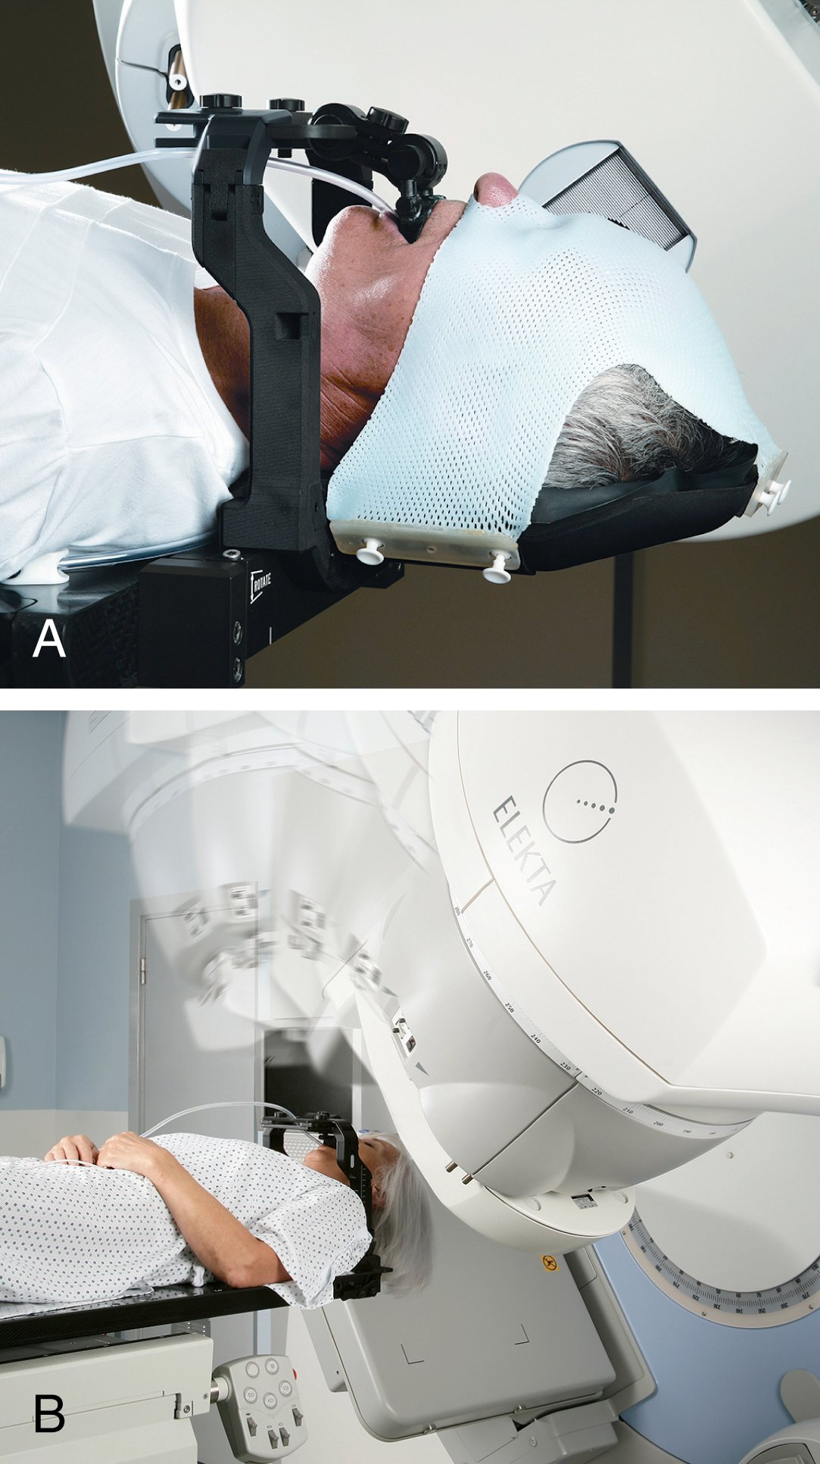FIG. 56.18 A, Patient in a stereotactic frame. B, Elekta’s Fraxion head frame helps ensure accuracy and precision in stereotactic radiation therapy (SRT) of cancer targets in the brain and cranium.
Courtesy Elekta, Stockholm, Sweden.

Nursing Management: Cranial Surgery

Nursing Implementation

Acute Care
The general preoperative and postoperative nursing care for the patient undergoing cranial surgery is similar regardless of the cause. It is similar to that for the patient with increased ICP. The patient (if conscious and coherent), caregiver, and family will be concerned about the potential physical and emotional problems that can result from surgery. The uncertainty about the prognosis and outcome requires compassionate nursing care in the preoperative period.
Preoperative teaching is important in allaying the fears of the patient, caregiver, and family and in preparing them for the postoperative period. Provide general information about the type of operation that will be done and what can be expected right after the operation. Explain that some hair may be shaved to allow for better exposure and to prevent contamination. The hair is usually removed in the operating room after induction of anesthesia. Tell them that the patient will be in an ICU or special care unit after surgery.
The main goal of care after cranial surgery is preventing increased ICP. Nursing management of the patient with increased ICP was outlined on pp. 1308–1311. Frequent assessment of the patient’s neurologic status is essential during the first 48 hours. Closely monitor fluid and electrolyte levels and serum osmolality to detect changes in sodium regulation, the onset of diabetes insipidus, or severe hypovolemia.
Monitor the patient for pain and nausea. Nausea and vomiting are common after surgery and are usually treated with antiemetics. The use of promethazine is discouraged because it can increase somnolence and alter the accuracy of a neurologic assessment.
Although the brain itself does not have pain receptors, patients often report headache caused by edema or pain at the incision site. Control pain with short-acting opioids and monitor neurologic status.
The surgical dressing is usually in place for a few days. With an incision over the skull in the anterior or middle fossa, the patient will return from the operating room with the head elevated at an angle of 30 to 45 degrees. The head of the bed should stay elevated at least 30 degrees unless the surgical approach is in the posterior fossa or a burr hole has been made. In these cases, the patient is generally kept flat or at a slight elevation (10 to 15 degrees) during the postoperative phase.
Turning and positioning the patient will depend on the site of the operation. If a bone flap has been removed (craniectomy), do not position the patient on the operative side. Place a sign at the head of the bed, alerting everyone of the craniectomy site and position of the surgical site. Observe the dressing for color, odor, and amount of drainage. Notify the HCP immediately of any excess bleeding or clear drainage. Checking drains for placement and assessing the area around the dressing are important. Scalp care should include meticulous care of the incision to prevent wound infection. Cleanse the area and treat it following agency protocol or the HCP’s orders. Once the dressing is removed, use an antiseptic soap for washing the scalp. The psychologic impact of hair removal can be lessened by using a wig, turban, scarves, or cap. For the patient who is receiving radiation, teach the patient to use a sunblock and head covering if any sun exposure is expected.

Ambulatory Care
The rehabilitative potential for a patient after cranial surgery depends on the reason for the surgery, postoperative course, and patient’s general state of health. Base your nursing interventions on a realistic appraisal of these factors. Specific rehabilitation potential cannot be determined until cerebral edema and increased ICP subside postoperatively. An overall goal is to foster independence for as long as possible and to the highest degree possible.
Take care to maintain as much function as possible through measures such as careful positioning, meticulous skin and mouth care, regular range-of-motion exercises, bowel and bladder care, and adequate nutrition. Address the needs and problems of each patient individually because many variables affect the plan.
Collaborate with other specialists. The physical therapist may provide an exercise plan to regain functional deficits. A speech therapist will help the patient regain communication skills. The patient’s mental and physical deterioration, including seizures, personality disorganization, apathy, and wasting, is difficult for both family and health care professionals. Cognitive and emotional residual deficits are often harder to accept than are motor and sensory losses. Social workers can help the patient and family adapt to changes in their home life, work, and financial circumstances.
Ethical/Legal Dilemmas
Withholding Treatment
Situation
C.J., a 26-yr-old patient in a permanent vegetative state, is diagnosed with her 15th bladder infection. As her home care nurse, you must determine whether to seek antibiotics for this infection. The family members have expressed a concern that no heroic measures be used to extend the life of their daughter and sister. However, they have been unwilling to stop providing enteral nutrition through a gastrostomy tube. Should antibiotics be withheld?
Ethical/Legal Points for Consideration
- • Patients in a persistent vegetative state do not recover.
- • The main legal issue here is who has the legal right to refuse or consent to treatment for this incapacitated patient. You need to know if a guardian has been appointed by the court or if her parents retain a form of guardianship to make health care decisions for her.
- • You need to know when the vegetative state began; that is, did the patient ever have the right to consent having reached the age of majority as a competent adult or did the vegetative state begin while she was a minor? If the patient did become a competent adult before the vegetative state, did she ever express any preference for quality-of-life and end-of-life decision making?
- • The courts have widespread legal precedents for accepting the decision of the patient’s guardian or parents or the patient’s clearly expressed preferences for quality-of-life decision making.
- • Life-sustaining treatment is any treatment that serves to prolong life without reversing the underlying medical condition. Life-sustaining treatment may include, but is not limited to, mechanical ventilation, renal dialysis, chemotherapy, antibiotics, and artificial nutrition and hydration.
- • There is no ethical distinction between withdrawing and withholding life-sustaining treatment. If there is not adequate evidence of the incompetent patient’s preferences and values, the decision should be based on the best interests of the patient (i.e., what outcome will most likely promote the patient’s well-being).
Discussion Questions
- 1. How would you approach C.J.’s family?
- 2. What are your feelings about providing nutrition, hydration, and treatments that will prolong life in a patient for whom there is no hope of recovery?
- 3. What options are available to the family for the care of their daughter once a decision is made about withholding antibiotics?

Inflammatory Conditions of the Brain
Brain abscesses, meningitis, and encephalitis are the most common inflammatory conditions of the brain and spinal cord (Table 56.16). Inflammation can be caused by bacteria, viruses, fungi, and chemicals (e.g., contrast media used in diagnostic tests, blood in the subarachnoid space). CNS infections may occur via the bloodstream, by extension from a primary site, or along cranial and spinal nerves.
The mortality rate for inflammatory conditions of the brain is about 10% to 15% in the general population, with higher rates in older and immunosuppressed patients. Some who recover have long-term neurologic deficits, including hearing loss.¹⁹

Bacterial Meningitis
Meningitis is an acute inflammation of the meningeal tissues surrounding the brain and spinal cord. Meningitis usually occurs in fall, winter, or early spring. It is often related to a viral respiratory disease. Older adults and persons who are debilitated are affected more often than the general population. College students living in dormitories and people living in institutions (e.g., prisoners) have a high risk for contracting meningitis. Untreated bacterial meningitis has a mortality rate of 50% to 100%.²⁰

Etiology and Pathophysiology
Streptococcus pneumoniae and Neisseria meningitidis are the leading causes of bacterial meningitis. N. meningitides has at least 13 different subtypes (serogroups) with 5 of them (A, B, C, Y, W) causing most cases. Haemophilus influenzae was once the most common cause of bacterial meningitis. However, the use of H. influenzae vaccine has resulted in a significant decrease in meningitis from this organism.
The organisms usually gain entry to the CNS through the upper respiratory tract or bloodstream. However, they may enter by direct extension from penetrating wounds of the skull or through fractured sinuses in basilar skull fractures.
The inflammatory response to the infection tends to increase CSF production with a moderate increase in ICP. In bacterial meningitis the purulent secretions quickly spread to other areas of the brain through the CSF and cover the cranial nerves and other intracranial structures. If this process extends into the brain parenchyma or if concurrent encephalitis is present, cerebral edema and increased ICP become more of a problem. Closely observe all patients for manifestations of increased ICP. ICP can increase from swelling around the dura and increased CSF volume.

Clinical Manifestations
Fever, severe headache, nausea, vomiting, and nuchal rigidity (neck stiffness) are key signs of meningitis. Photophobia, a decreased LOC, and signs of increased ICP may be present. Coma is associated with a poor prognosis. It occurs in 5% to 10% of patients with bacterial meningitis. Seizures occur in one third of all cases. The headache becomes progressively worse and may be accompanied by vomiting and irritability.
If the infecting organism is a meningococcus, a skin rash is common. Petechiae may be seen on the trunk, lower extremities, and mucous membranes. A tumbler test can be done by pressing the base of a drinking glass against the rash. The rash does not blanch or fade under pressure.

Complications
The most common acute complication of bacterial meningitis is increased ICP. Most patients have increased ICP. It is the major cause of an altered mental status.
Another complication is residual neurologic dysfunction. It often involves many cranial nerves. Cranial nerve irritation can have serious sequelae. The optic nerve (CN II) is compressed by increased ICP. Papilledema is often present, and blindness may occur. When CN III, CN IV, and CN VI are irritated, ocular movements are affected. Ptosis, unequal pupils, and diplopia are common. Irritation of CN V results in sensory losses and loss of the corneal reflex. Irritation of CN VII results in facial paresis. Irritation of CN VIII causes tinnitus, vertigo, and deafness. The dysfunction usually disappears within a few weeks. However, hearing loss may be permanent.
TABLE 56.16 Comparison of Cerebral Inflammatory Conditions
 | Meningitis | Encephalitis | Brain Abscess
Cause | Bacteria (Streptococcus pneumoniae, Neisseria meningitidis, group B streptococci, viruses, fungi) | Bacteria, fungi, parasites, herpes simplex virus (HSV), other viruses (e.g., West Nile virus) | Streptococci, staphylococci through bloodstream
Cerebrospinal Fluid (Reference Interval)
• Pressure (<20 mm H₂O) | Increased  Bacterial: 200–500  Viral: ≤250 | Normal to slight increase | Increased
• WBC count (0–5 cells/μL) | Bacterial: >1000/μL (mainly neutrophils)  Viral: 25–500/μL (mainly lymphocytes) | 500/μL, neutrophils (early), lymphocytes (later) | 25–300/μL (neutrophils)
• Protein (15–45 mg/dL [0.15–0.45 g/L]) | Bacterial: >500 mg/dL  Viral: 50–500 mg/dL | Slight increase | Normal
• Glucose (50–77 mg/dL [2.2–3.9 mmol/L]) | Bacterial: Decreased 5–40  Viral: Normal or low >40 | Normal | Low or absent
• Appearance | Bacterial: Turbid, cloudy  Viral: Clear or cloudy | Clear | Clear
Diagnostic Studies | CT scan, Gram stain, smear, culture, PCR | CT scan, EEG, MRI, PET, PCR, IgM antibodies to virus in serum or CSF | CT scan
Treatment | Antibiotics, dexamethasone, supportive care, prevention of ↑ ICP | Supportive care, prevention of ↑ ICP, acyclovir (Zovirax) for HSV | Antibiotics, incision and drainage  Supportive care
∗PCR is used to detect viral RNA or DNA.
IgM, immunoglobulin M; PCR, polymerase chain reaction.
Hemiparesis, dysphasia, and hemianopsia may occur. These signs usually resolve over time. If they do not, suspect a cerebral abscess, subdural empyema, subdural effusion, or persistent meningitis. Acute cerebral edema may cause seizures, CN III palsy, bradycardia, hypertensive coma, and death.
Headaches may occur for months after the diagnosis of meningitis until the irritation and inflammation have completely resolved. It is important to implement pain management for chronic headaches.
A noncommunicating hydrocephalus may occur if the exudate causes adhesions that prevent the normal flow of CSF from the ventricles. CSF reabsorption by the arachnoid villi may be obstructed by the exudate. In this situation, surgical implantation of a shunt is the only treatment.
Waterhouse-Friderichsen syndrome is a complication of meningococcal meningitis. The syndrome is manifested by petechiae, disseminated intravascular coagulation (DIC), adrenal hemorrhage, and circulatory collapse. DIC and shock, which are some of the most serious complications of meningitis, are associated with meningococcemia. DIC is discussed in detail in Chapter 30.

Diagnostic Studies
When a patient has manifestations suggestive of bacterial meningitis, a blood culture and CT scan should be done. Diagnosis is usually verified by doing an LP with analysis of the CSF (Table 56.16). An LP should be done only after the CT scan has ruled out an obstruction in the foramen magnum to prevent a fluid shift resulting in herniation.
Specimens of the CSF, sputum, and nasopharyngeal secretions are taken for culture before the start of antibiotic therapy to identify the causative organism. A Gram stain is done to detect bacteria. The predominant white blood cell type in the CSF with bacterial meningitis is neutrophils.
X-rays of the skull may show infected sinuses. CT scans and MRI may be normal in uncomplicated meningitis. In other cases, CT scans may reveal evidence of increased ICP or hydrocephalus.

Interprofessional Care
Bacterial meningitis is a medical emergency. Rapid diagnosis based on history and physical examination is crucial because the patient is usually in a critical state when health care is sought. When meningitis is suspected, antibiotic therapy is begun after the collection of specimens for cultures, even before the diagnosis is confirmed (Table 56.17).
Ampicillin, penicillin, vancomycin, cefuroxime (Ceftin), cefotaxime, ceftriaxone, ceftizoxime, and ceftazidime are the main drugs given to treat bacterial meningitis. Dexamethasone may be given before or with the first dose of antibiotics. Collaborate with the HCP to manage the headache, fever, and nuchal rigidity often associated with meningitis.

Nursing Management: Bacterial Meningitis

Nursing Assessment
Initial assessment should include vital signs, neurologic assessment, fluid intake and output, and evaluation of the lungs and skin.

Nursing Diagnoses
Nursing diagnoses for the patient with bacterial meningitis may include:
- • Decreased intracranial adaptive capacity
- • Ineffective tissue perfusion
- • Hyperthermia
- • Acute pain
Additional information on nursing diagnoses and interventions for the patient with bacterial meningitis is presented in eNursing Care Plan 56.2 (available on the website for this chapter).

Planning
The overall goals for the patient with bacterial meningitis are to (1) return to maximal neurologic functioning, (2) resolve the infection, and (3) control pain and discomfort.

Nursing Implementation

Health Promotion
Prevention of respiratory tract infections through vaccination programs for pneumococcal pneumonia and influenza is important. Meningococcal vaccines are available that protect against the serogroups of meningococcal disease that are most often seen in the United States. They will not prevent all cases. Two types of meningococcal vaccines are available in the United States:
- • Meningococcal conjugate vaccines (MCV4) (Menactra, Menveo)
- • Serogroup B meningococcal vaccines (Bexsero, Trumenba)
Early and vigorous treatment of respiratory tract and ear infections is important. Persons who have close contact with anyone who has bacterial meningitis should receive prophylactic antibiotics.

Acute Care
The patient with bacterial meningitis is usually acutely ill. The fever is high, and head pain is severe. Irritation of the cerebral cortex may result in seizures. The changes in mental status and LOC depend on the degree of increased ICP. Assess and record vital signs, neurologic status, fluid intake and output, skin, and lung fields at regular intervals based on the patient’s condition.
TABLE 56.17 Interprofessional CareBacterial Meningitis
Diagnostic Assessment
- • History and physical examination
- • Analysis of CSF (for protein, WBC, and glucose), Gram stain, and culture
- • CBC, coagulation profile, electrolyte levels, glucose, platelet count
- • Blood culture
- • CT scan, MRI, PET scan
- • Skull x-ray studies
Management
- • Rest
- • IV fluid
- • Hypothermia
Drug Therapy
- • IV antibiotics

  - • ampicillin, penicillin
  - • cephalosporin (e.g., cefotaxime, ceftriaxone)
- • codeine for headache
- • dexamethasone
- • acetaminophen or aspirin for temperature >100.4° F (38° C)
- • phenytoin IV
- • mannitol (Osmitrol) IV for diuresis
Head and neck pain with movement requires attention. Codeine provides some pain relief without undue sedation for most patients. Assist the patient to a position of comfort, often curled up with the head slightly extended. The head of the bed should be slightly elevated. A darkened room and a cool cloth over the eyes relieve the discomfort of photophobia.
For the patient with delirium, low lighting may decrease hallucinations. All patients have some degree of mental distortion and hypersensitivity. They may be frightened and misinterpret the environment. Make every attempt to minimize environmental stimuli and prevent injury. A familiar person at the bedside may have a calming effect. Be efficient with care while conveying an attitude of caring and unhurried gentleness. The use of touch and a soothing voice to give simple explanations of activities is helpful. If seizures occur, make appropriate observations and take protective measures. Give antiseizure drugs, such as phenytoin (Dilantin) or levetiracetam (Keppra), as ordered. Manage problems associated with increased ICP (see the section on increased ICP on pp. 1308–1311).
Fever is vigorously treated because it increases cerebral edema and the risk for seizures. In addition, neurologic damage may result from an extremely fever over a prolonged time. Acetaminophen or aspirin may be used to reduce fever. If the fever is resistant to aspirin or acetaminophen, more vigorous means are needed (e.g., cooling blanket). Take care not to reduce the temperature too rapidly because shivering may result, causing a rebound effect and increasing the temperature and ICP. Wrap the extremities in soft towels or a blanket covered with a sheet to reduce shivering. If a cooling blanket is not available or desirable, tepid sponge baths with water may be effective in lowering the temperature. Protect the skin from excessive drying and injury and prevent breaks in the skin.
Because high fever increases the metabolic rate and thus insensible fluid loss, assess the patient for dehydration and adequacy of fluid intake. Diaphoresis further increases fluid losses and should be noted on the output record. Calculate replacement fluids as 800 mL/day for respiratory losses and 100 mL for each degree of temperature above 100.4° F (38° C). Supplemental feeding (e.g., enteral nutrition) to maintain adequate nutritional intake may be needed. Follow the designated antibiotic schedule to maintain therapeutic blood levels.
Meningitis generally requires respiratory isolation until the cultures are negative. Meningococcal meningitis is highly contagious, while other causes of meningitis may pose minimal to no infection risk with patient contact. However, standard precautions are essential to protect the patient and nurse.

Ambulatory Care
After the acute period has passed, the patient needs several weeks of recovery before resuming normal activities. In this period, stress the importance of adequate nutrition, with an emphasis on a high-protein, high-calorie diet in small, frequent feedings.
Muscle rigidity may persist in the neck and backs of the legs. Progressive range-of-motion exercises and warm baths are useful. Have the patient gradually increase activity as tolerated but encourage adequate rest and sleep.
Residual effects can result in sequelae such as dementia, seizures, deafness, hemiplegia, and hydrocephalus. Assess vision, hearing, cognitive skills, and motor and sensory abilities after recovery, with appropriate referrals as indicated. Throughout the acute and recovery periods, be aware of the anxiety and stress felt by the caregiver and other family members.

Evaluation
The expected outcomes are that the patient with bacterial meningitis will
- • Have appropriate cognitive function
- • Be oriented to person, place, and time
- • Maintain body temperature within normal range
- • Report satisfaction with pain control

Viral Meningitis
The most common causes of viral meningitis are enteroviruses, arboviruses, human immunodeficiency virus, and herpes simplex virus (HSV). Enteroviruses most often spread through direct contact with respiratory secretions. Viral meningitis usually presents as a headache, fever, photophobia, and stiff neck.¹⁹ The fever may be moderate or high.
The Xpert EV test can rapidly diagnose viral meningitis. A sample of CSF is used to determine if enterovirus is present, and results are available within hours of symptom onset.²⁰
The CSF can be clear or cloudy, and the typical finding is lymphocytosis. Organisms are not seen on Gram stain or acid-fast smears. Polymerase chain reaction (PCR) used to detect viral-specific deoxyribonucleic acid (DNA) or ribonucleic acid (RNA) is a sensitive method for diagnosing CNS viral infections.
Antibiotics should be given after the LP while awaiting the results of the CSF analysis. Antibiotics are the best defense for bacterial meningitis. We can easily discontinue them if the meningitis is found to be viral.
Viral meningitis is managed symptomatically because the disease is self-limiting. Full recovery is expected. Rare sequelae include persistent headaches, mild mental impairment, and incoordination.

Brain Abscess
Brain abscess is an accumulation of pus within the brain tissue from a local or systemic infection. Direct extension from an ear, tooth, mastoid, or sinus infection is the main cause. Other causes for brain abscess formation include spread from a distant site (e.g., pulmonary infection, bacterial endocarditis), skull fracture, and prior brain trauma or surgery. Streptococci and Staphylococcus aureus are the most common infective organisms.
Manifestations are similar to those of meningitis and encephalitis and include headache, fever, and nausea and vomiting. Signs of increased ICP may include drowsiness, confusion, and seizures. Focal symptoms may reflect the local area of the abscess. For example, visual field defects or psychomotor seizures are common with a temporal lobe abscess. Visual impairment and hallucinations may accompany an occipital abscess. CT and MRI are used to diagnose a brain abscess.
Antimicrobial therapy is the primary treatment for brain abscess. Other manifestations are treated symptomatically. If drug therapy is not effective, the abscess may have to be drained or removed if it is encapsulated.
Nursing measures are similar to those for management of meningitis or increased ICP. If surgical drainage or removal is the treatment of choice, nursing care is similar to that of a patient having cranial surgery.

Encephalitis
Encephalitis, an acute inflammation of the brain, is a serious and sometimes fatal disease. Several thousand cases occur in the United States each year. It is usually caused by a virus. Many different viruses can cause encephalitis. Some are associated with certain seasons of the year or endemic to certain geographic areas.
Ticks and mosquitoes transmit epidemic encephalitis. Examples of encephalitis include eastern equine, La Crosse, St. Louis, West Nile, and western equine.²¹ Nonepidemic encephalitis may occur as a complication of measles, chickenpox, or mumps. HSV encephalitis is the most common cause of acute nonepidemic viral encephalitis. Cytomegalovirus encephalitis occurs in patients with acquired immunodeficiency syndrome (AIDS).

Clinical Manifestations and Diagnostic Studies
Encephalitis can be acute or subacute. The onset is typically nonspecific, with fever, headache, nausea, and vomiting. Signs of encephalitis appear on day 2 or 3 and may vary from minimal changes in mental status to coma. Virtually any CNS abnormality can occur, including hemiparesis, tremors, seizures, cranial nerve palsies, personality changes, memory impairment, amnesia, and dysphasia.
Early diagnosis and treatment of viral encephalitis are essential for favorable outcomes. Diagnostic findings are shown in Table 56.16. Brain imaging techniques include CT, MRI, and PET. PCR tests allow for early detection of HSV and West Nile encephalitis. West Nile virus should be strongly considered in adults over 50 years old who develop encephalitis or meningitis in summer or early fall. The best diagnostic test for West Nile virus is a blood test that detects viral RNA. This test is also used to screen donated blood, organs, cells, and tissues.

Interprofessional and Nursing Care
Prevention of encephalitis focuses on mosquito control. Measures include cleaning rain gutters, removing old tires, draining bird baths, and removing water where mosquitoes can breed. Insect repellent should be used during mosquito season.
Interprofessional and nursing management of encephalitis, including West Nile virus infection, is symptomatic and supportive. In the initial stages of encephalitis, many patients need intensive care.
Acyclovir (Zovirax) is used to treat encephalitis caused by HSV infection. Its use reduces mortality rates, although neurologic complications may still occur. For maximal benefit, treatment should start before the onset of coma. Treat seizure disorders with antiseizure drugs. Prophylactic treatment with antiseizure drugs may be used in severe cases of encephalitis. Treatment of cytomegalovirus encephalitis in AIDS patients is discussed in

